**Exercise 1: Implementing the Singleton Pattern (Mandatory)**

**Code:**

public class SingletonPattern {

public static void main(String[] args) {

Logger logger1 = Logger.getInstance();

logger1.log("Log from logger1");

Logger logger2 = Logger.getInstance();

logger2.log("Log from logger2");

if (logger1 == logger2) {

System.out.println("Singleton works! Only one instance.");

} else {

System.out.println("Singleton failed.");

}

}

}

class Logger {

private static Logger instance;

private Logger() {

System.out.println("Logger initialized.");

}

public static Logger getInstance() {

if (instance == null) {

instance = new Logger();

}

return instance;

}

public void log(String message) {

System.out.println("[LOG] " + message);

}

}

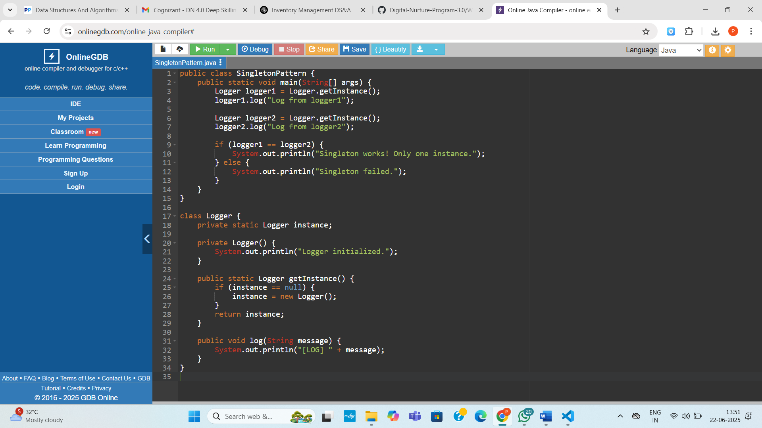

**Output:**

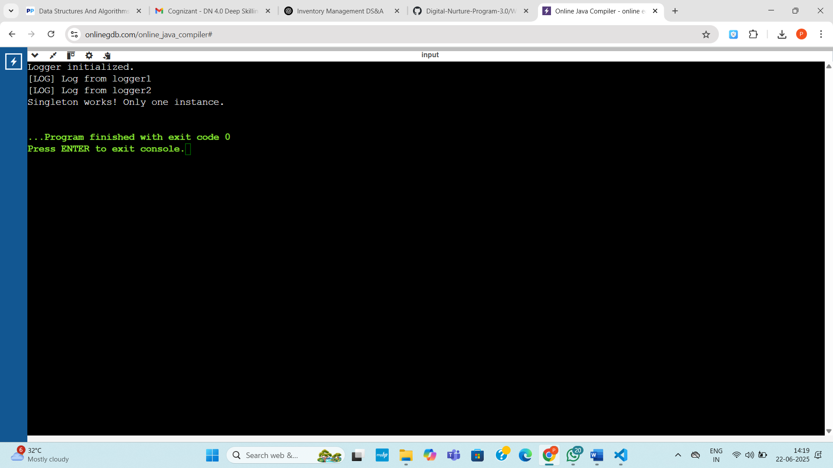

**Exercise 2: Implementing the Factory Method Pattern (Mandatory)**

**Code:**

interface Document {

void open();

void save();

void close();

}

class WordDocument implements Document {

public void open() {

System.out.println("Opening Word document...");

}

public void save() {

System.out.println("Saving Word document...");

}

public void close() {

System.out.println("Closing Word document...");

}

}

class PdfDocument implements Document {

public void open() {

System.out.println("Opening PDF document...");

}

public void save() {

System.out.println("Saving PDF document...");

}

public void close() {

System.out.println("Closing PDF document...");

}

}

class ExcelDocument implements Document {

public void open() {

System.out.println("Opening Excel document...");

}

public void save() {

System.out.println("Saving Excel document...");

}

public void close() {

System.out.println("Closing Excel document...");

}

}

// Abstract Factory

abstract class DocumentFactory {

public abstract Document createDocument();

}

// Concrete Factories

class WordDocumentFactory extends DocumentFactory {

public Document createDocument() {

return new WordDocument();

}

}

class PdfDocumentFactory extends DocumentFactory {

public Document createDocument() {

return new PdfDocument();

}

}

class ExcelDocumentFactory extends DocumentFactory {

public Document createDocument() {

return new ExcelDocument();

}

}

public class Main {

public static void main(String[] args) {

DocumentFactory wordFactory = new WordDocumentFactory();

Document word = wordFactory.createDocument();

word.open();

word.save();

word.close();

System.out.println();

DocumentFactory pdfFactory = new PdfDocumentFactory();

Document pdf = pdfFactory.createDocument();

pdf.open();

pdf.save();

pdf.close();

System.out.println();

DocumentFactory excelFactory = new ExcelDocumentFactory();

Document excel = excelFactory.createDocument();

excel.open();

excel.save();

excel.close();

}

}

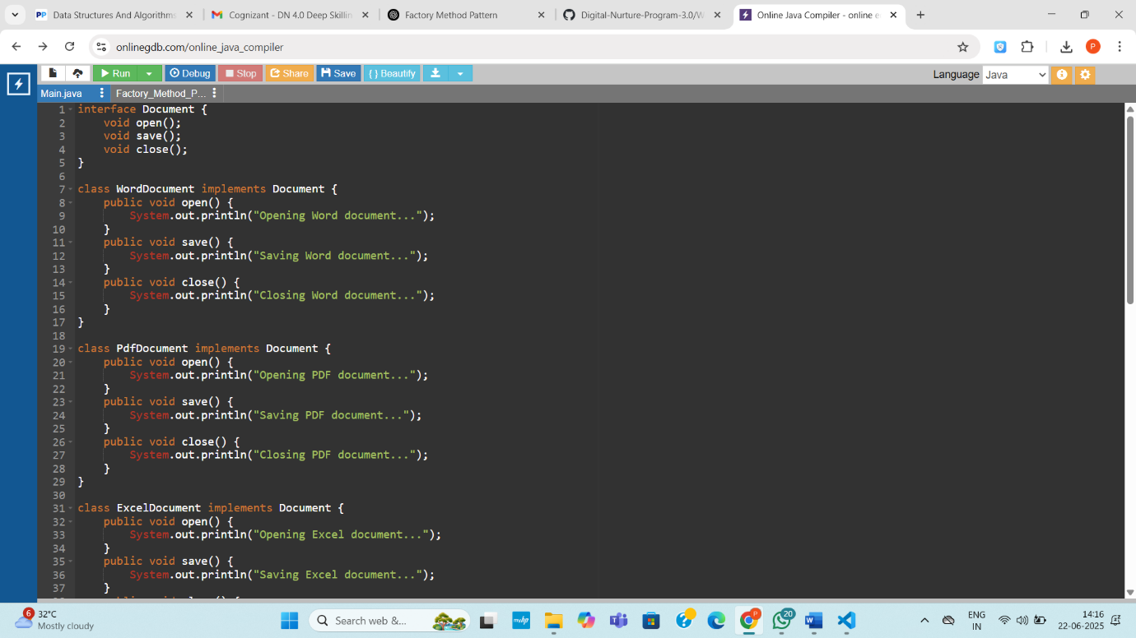

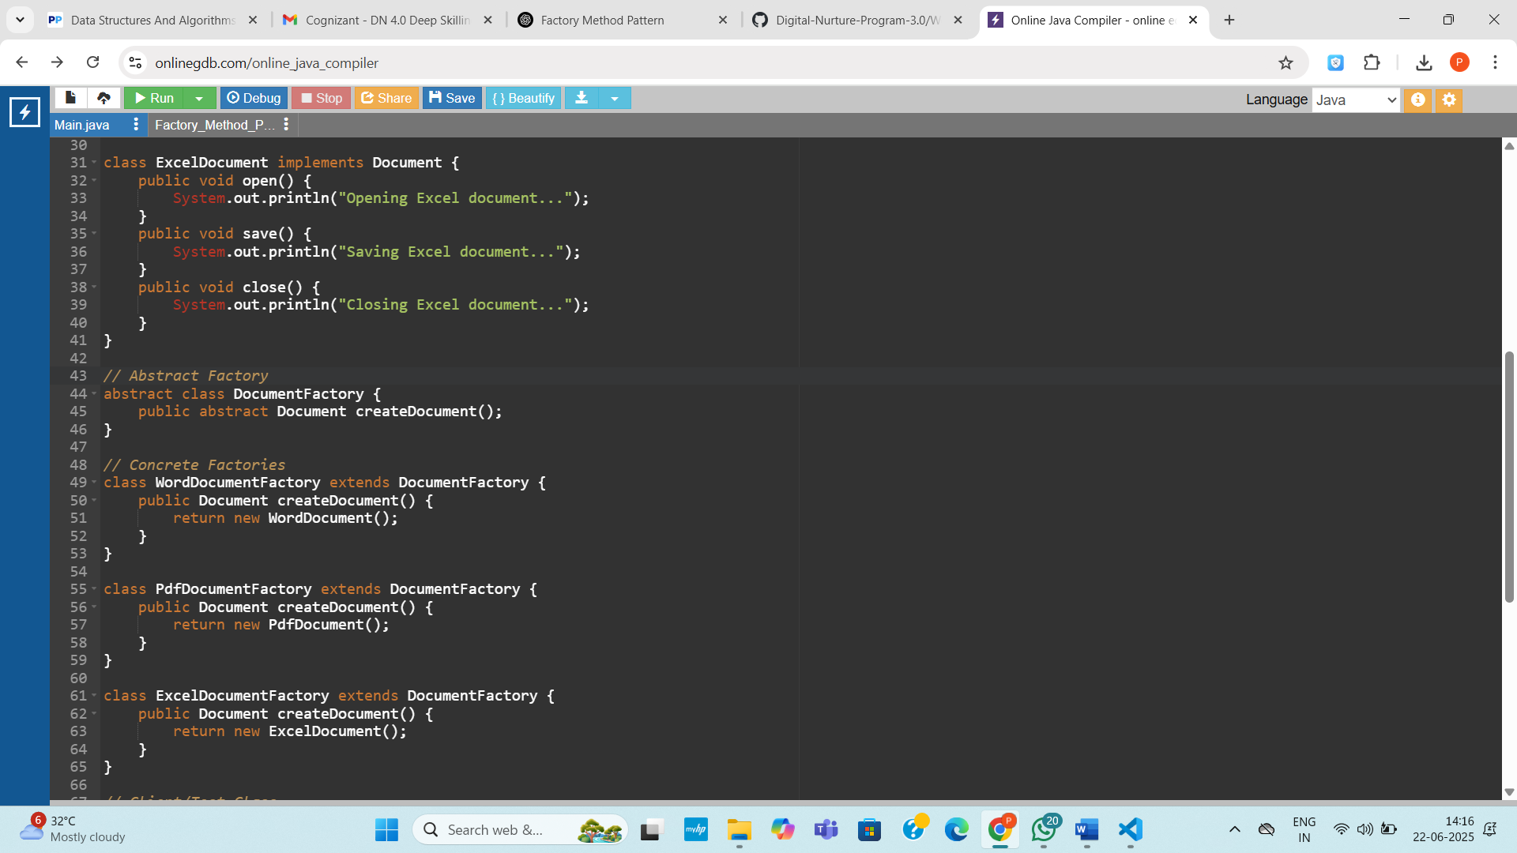

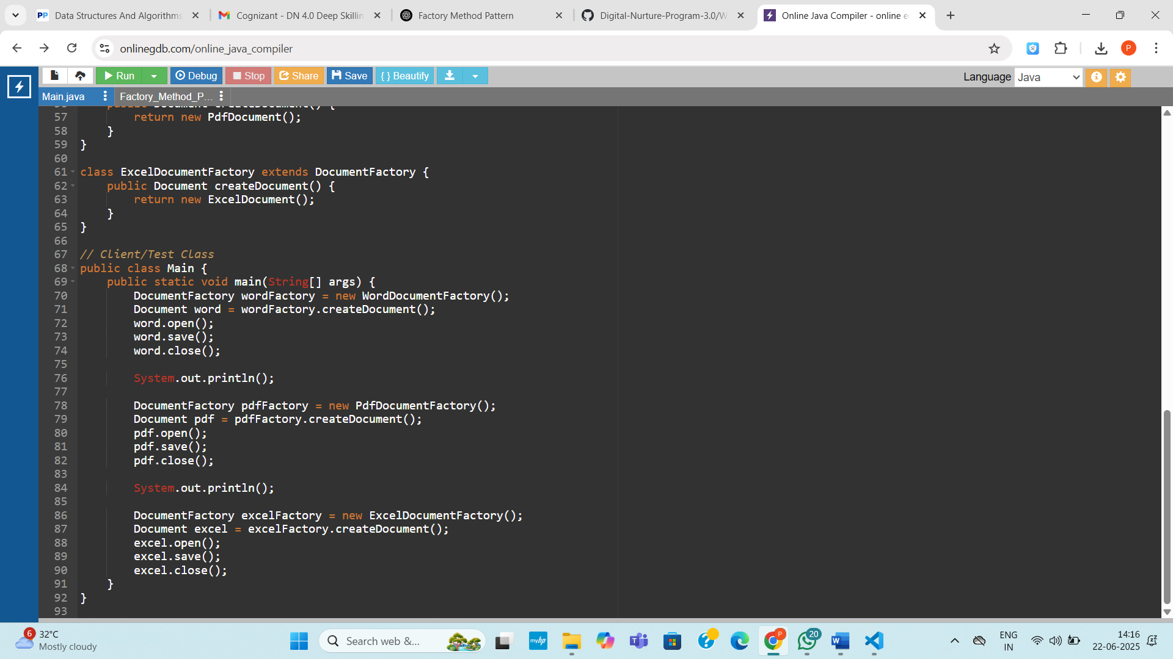

**Output:**

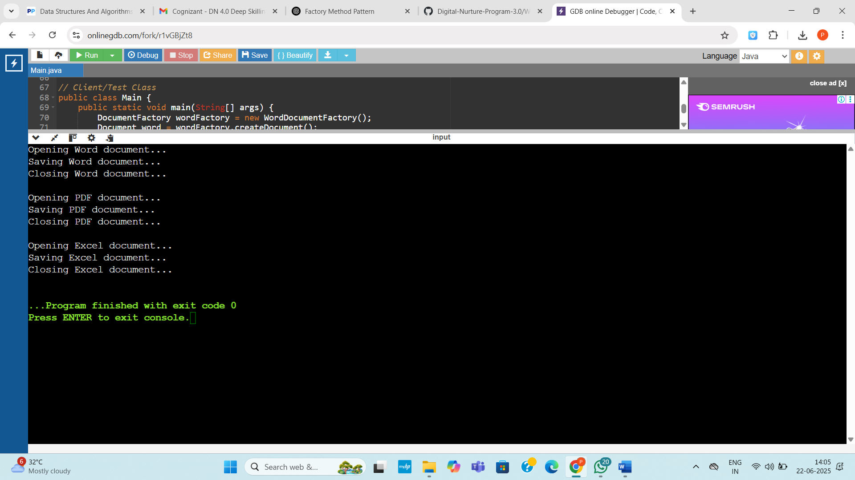

**Exercise 3: Implementing the Builder Pattern**

**Code:**

public class Main {

// Product class

static class Computer {

private String cpu;

private int ram;

private int storage;

private boolean hasGraphicsCard;

private String operatingSystem;

private boolean isSSD; // New field

// Private constructor

private Computer(Builder builder) {

this.cpu = builder.cpu;

this.ram = builder.ram;

this.storage = builder.storage;

this.hasGraphicsCard = builder.hasGraphicsCard;

this.operatingSystem = builder.operatingSystem;

this.isSSD = builder.isSSD;

}

// Display configuration

public void displayConfiguration() {

System.out.println("CPU: " + cpu);

System.out.println("RAM: " + ram + " GB");

System.out.println("Storage: " + storage + " GB");

System.out.println("SSD: " + (isSSD ? "Yes" : "No"));

System.out.println("Graphics Card: " + (hasGraphicsCard ? "Yes" : "No"));

System.out.println("Operating System: " + (operatingSystem != null ? operatingSystem : "Not Installed"));

}

// Builder class

static class Builder {

private String cpu;

private int ram;

private int storage;

private boolean hasGraphicsCard;

private String operatingSystem;

private boolean isSSD; // New field

public Builder setCpu(String cpu) {

this.cpu = cpu;

return this;

}

public Builder setRam(int ram) {

this.ram = ram;

return this;

}

public Builder setStorage(int storage) {

this.storage = storage;

return this;

}

public Builder setGraphicsCard(boolean hasGraphicsCard) {

this.hasGraphicsCard = hasGraphicsCard;

return this;

}

public Builder setOperatingSystem(String os) {

this.operatingSystem = os;

return this;

}

public Builder setSSD(boolean isSSD) {

this.isSSD = isSSD;

return this;

}

// Build method

public Computer build() {

return new Computer(this);

}

}

}

// Main method to test

public static void main(String[] args) {

// Gaming PC

Computer gamingPC = new Computer.Builder()

.setCpu("Intel Core i9")

.setRam(32)

.setStorage(1000)

.setSSD(true)

.setGraphicsCard(true)

.setOperatingSystem("Windows 11")

.build();

// Office PC

Computer officePC = new Computer.Builder()

.setCpu("Intel Core i5")

.setRam(16)

.setStorage(512)

.setSSD(false)

.setGraphicsCard(false)

.setOperatingSystem("Ubuntu")

.build();

// Print configurations

System.out.println("Gaming PC Configuration:");

gamingPC.displayConfiguration();

System.out.println("\nOffice PC Configuration:");

officePC.displayConfiguration();

}

}

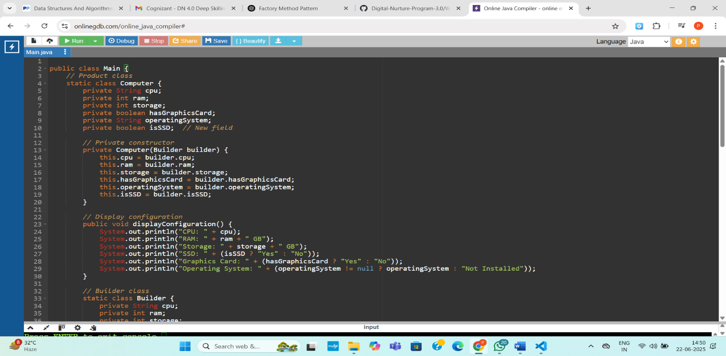

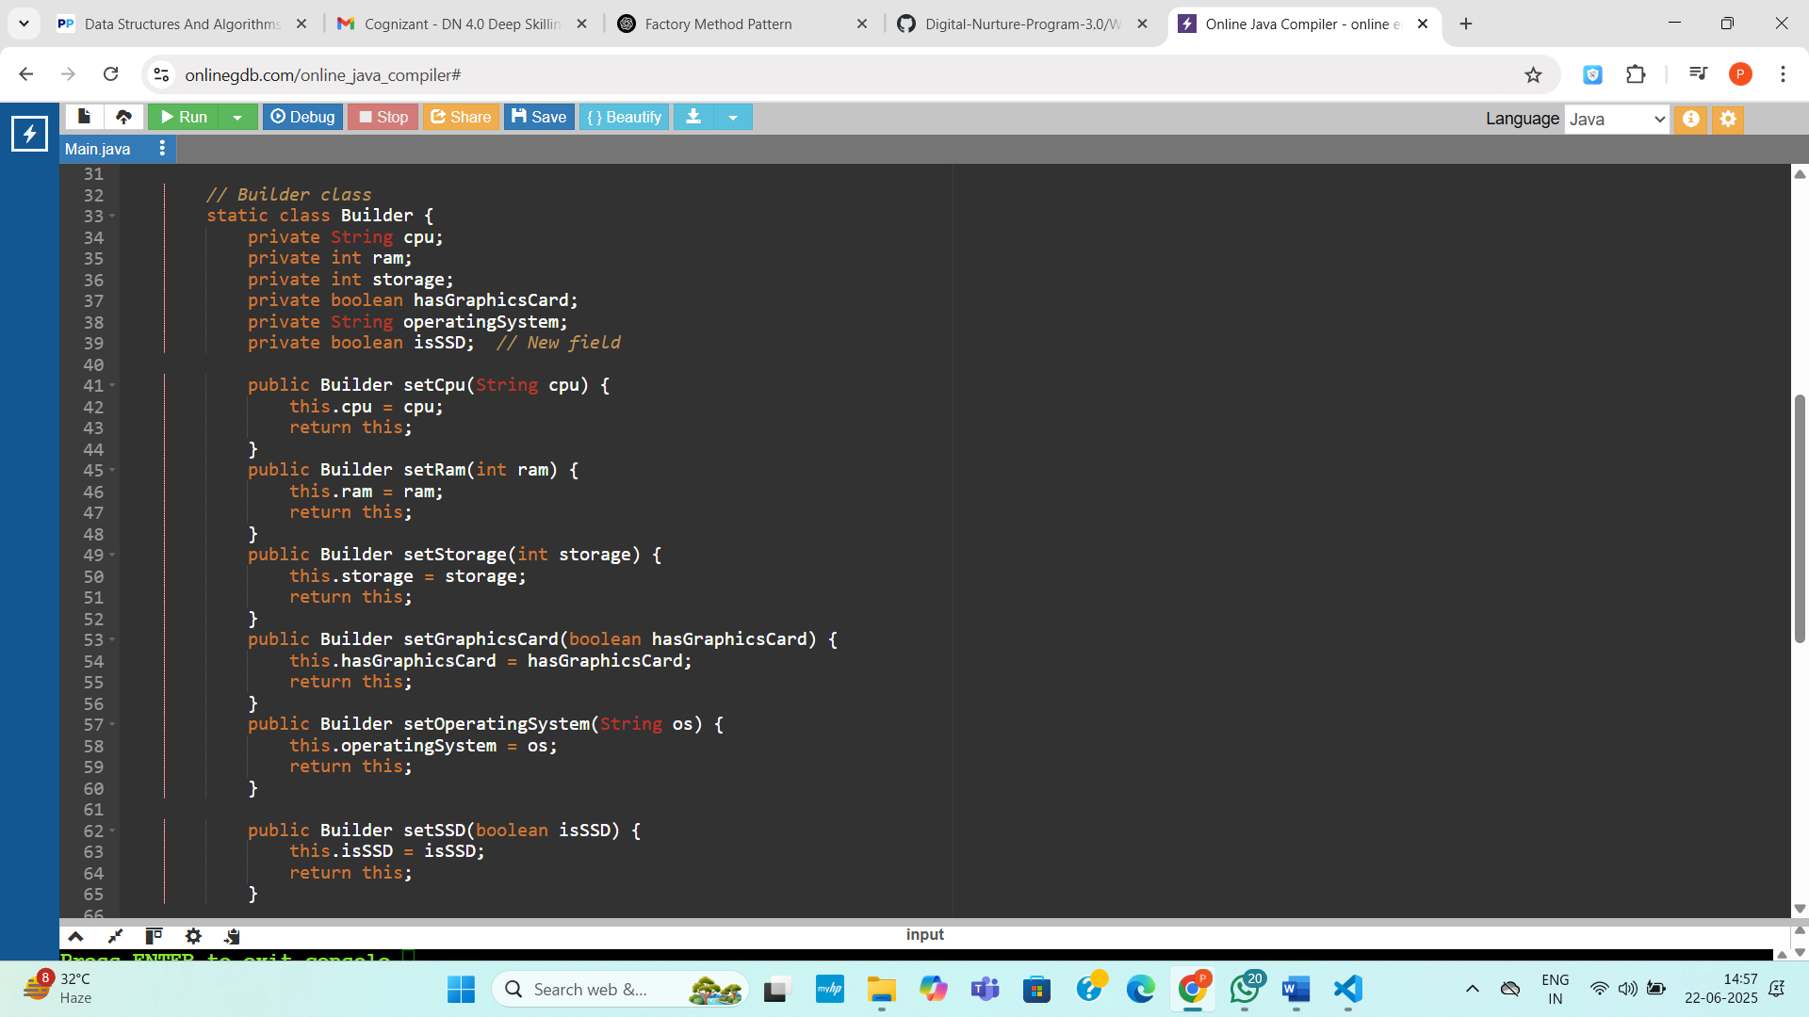

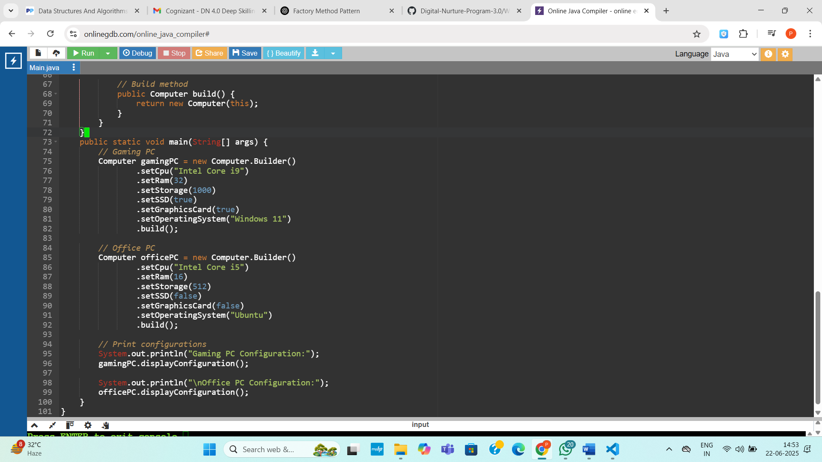

**Output:**

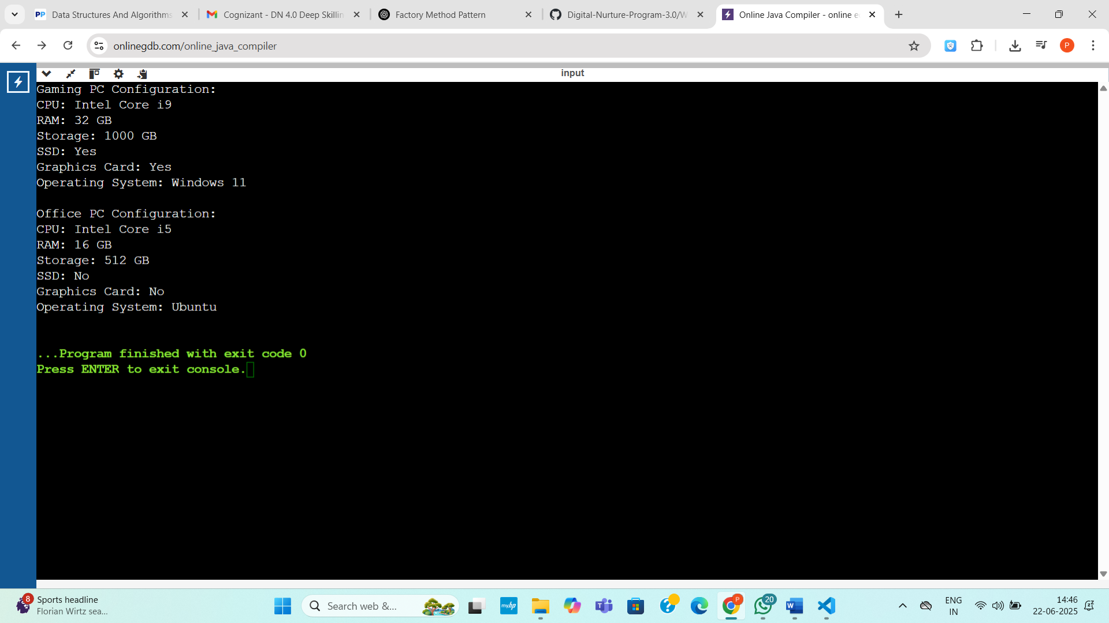

**Exercise 3: Implementing the Builder Pattern**

**Code:**

public class BuilderPatternExample {

public static void main(String[] args) {

// Basic configuration

Computer basicComputer = new Computer.Builder("Intel i5", "8GB")

.build();

// Advanced configuration

Computer gamingComputer = new Computer.Builder("Intel i9", "32GB")

.setStorage("1TB")

.setGraphicsCard("NVIDIA RTX 4080")

.setIsSSD(true)

.build();

// Custom configuration

Computer officeComputer = new Computer.Builder("AMD Ryzen 5", "16GB")

.setStorage("512GB")

.setIsSSD(true)

.build();

System.out.println(basicComputer);

System.out.println(gamingComputer);

System.out.println(officeComputer);

}

}

class Computer {

private String CPU;

private String RAM;

private String storage;

private String graphicsCard;

private boolean isSSD;

private Computer(Builder builder) {

this.CPU = builder.CPU;

this.RAM = builder.RAM;

this.storage = builder.storage;

this.graphicsCard = builder.graphicsCard;

this.isSSD = builder.isSSD;

}

public static class Builder {

private String CPU;

private String RAM;

private String storage;

private String graphicsCard;

private boolean isSSD;

public Builder(String CPU, String RAM) {

this.CPU = CPU;

this.RAM = RAM;

}

public Builder setStorage(String storage) {

this.storage = storage;

return this;

}

public Builder setGraphicsCard(String graphicsCard) {

this.graphicsCard = graphicsCard;

return this;

}

public Builder setIsSSD(boolean isSSD) {

this.isSSD = isSSD;

return this;

}

public Computer build() {

return new Computer(this);

}

}

@Override

public String toString() {

return "Computer [CPU=" + CPU + ", RAM=" + RAM + ", Storage=" + storage +

", GraphicsCard=" + graphicsCard + ", SSD=" + isSSD + "]";

}

}

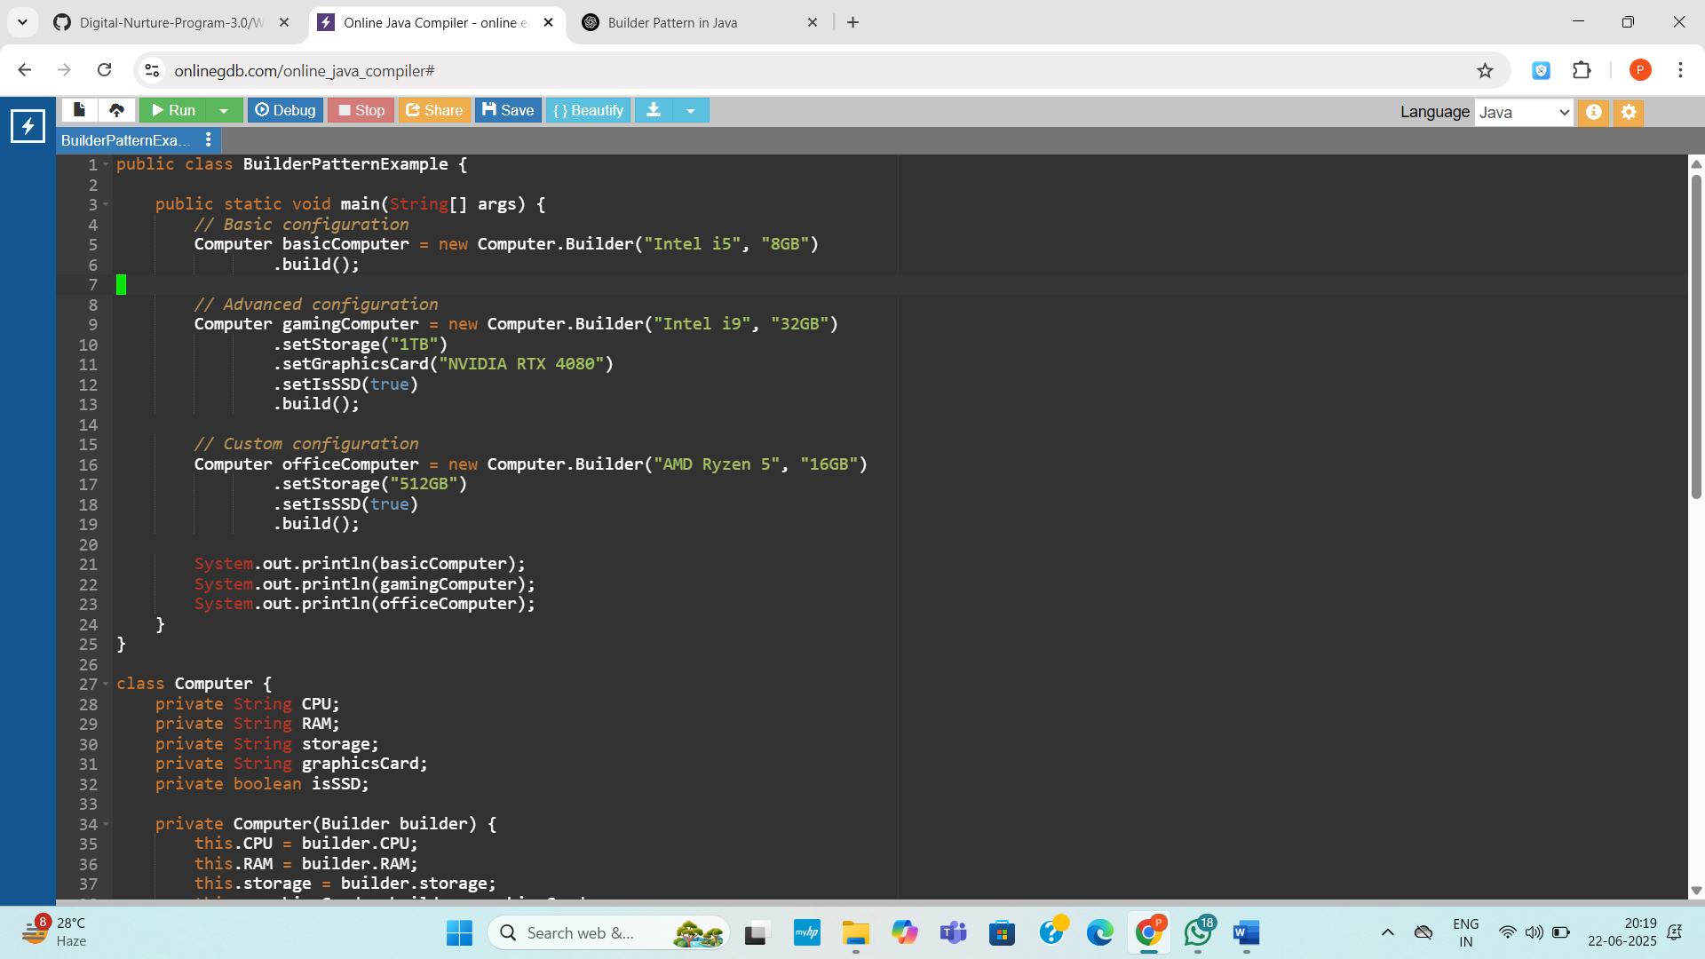

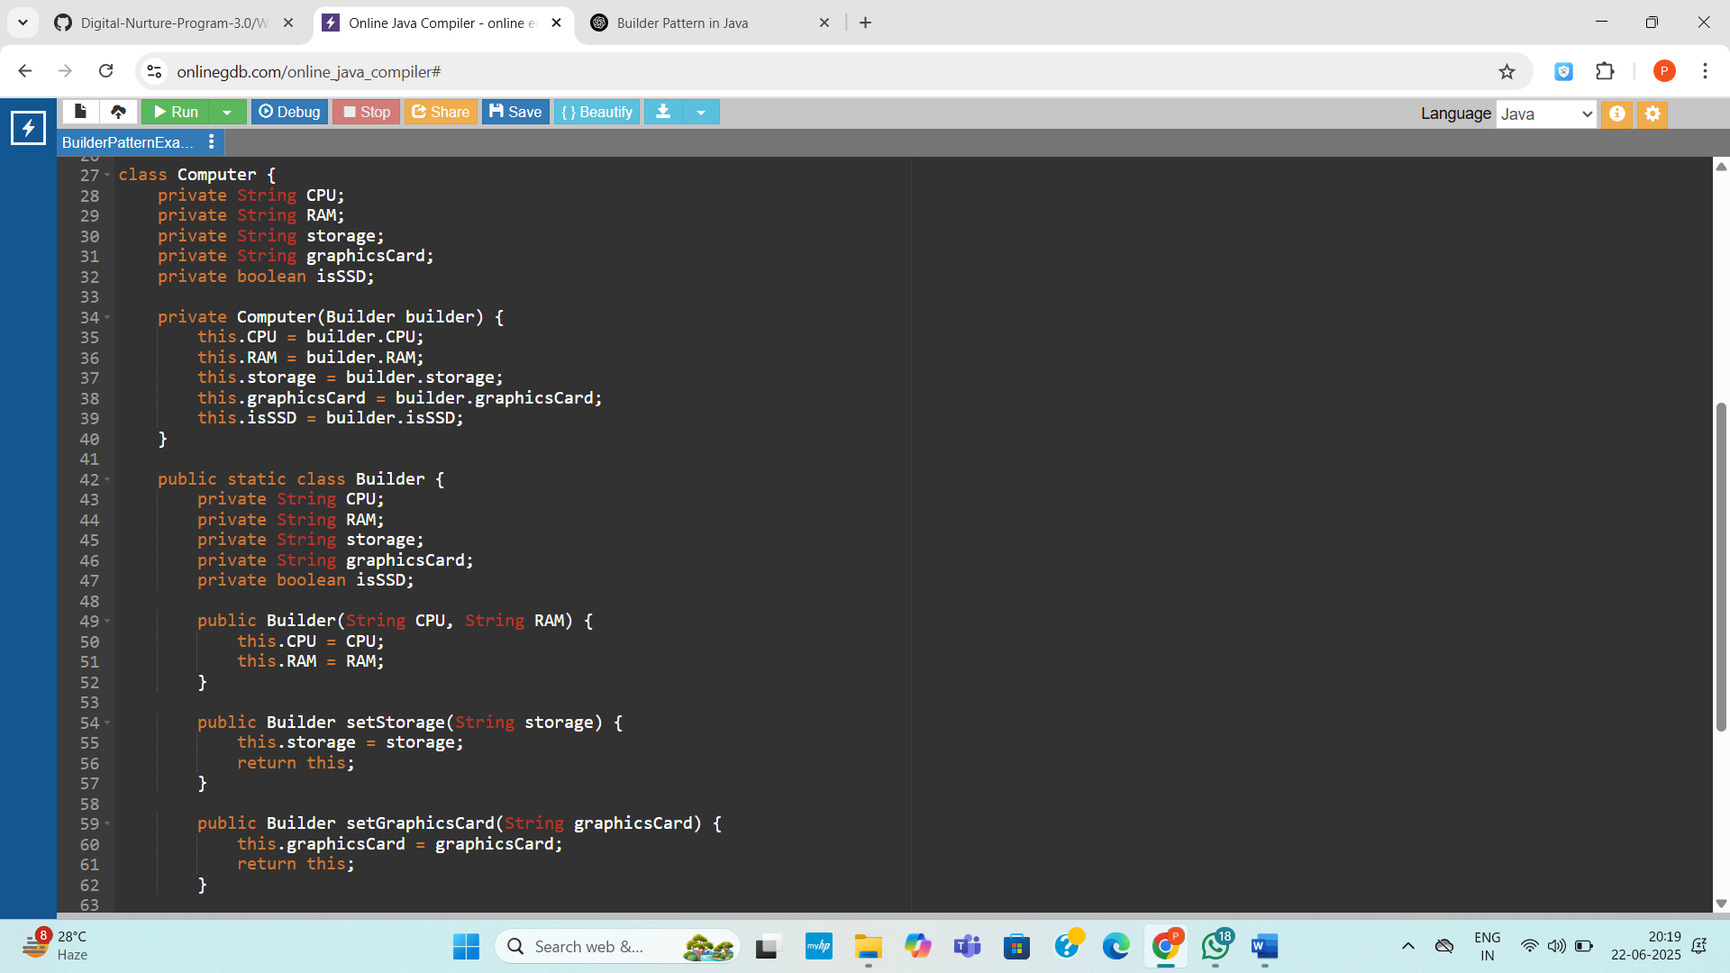

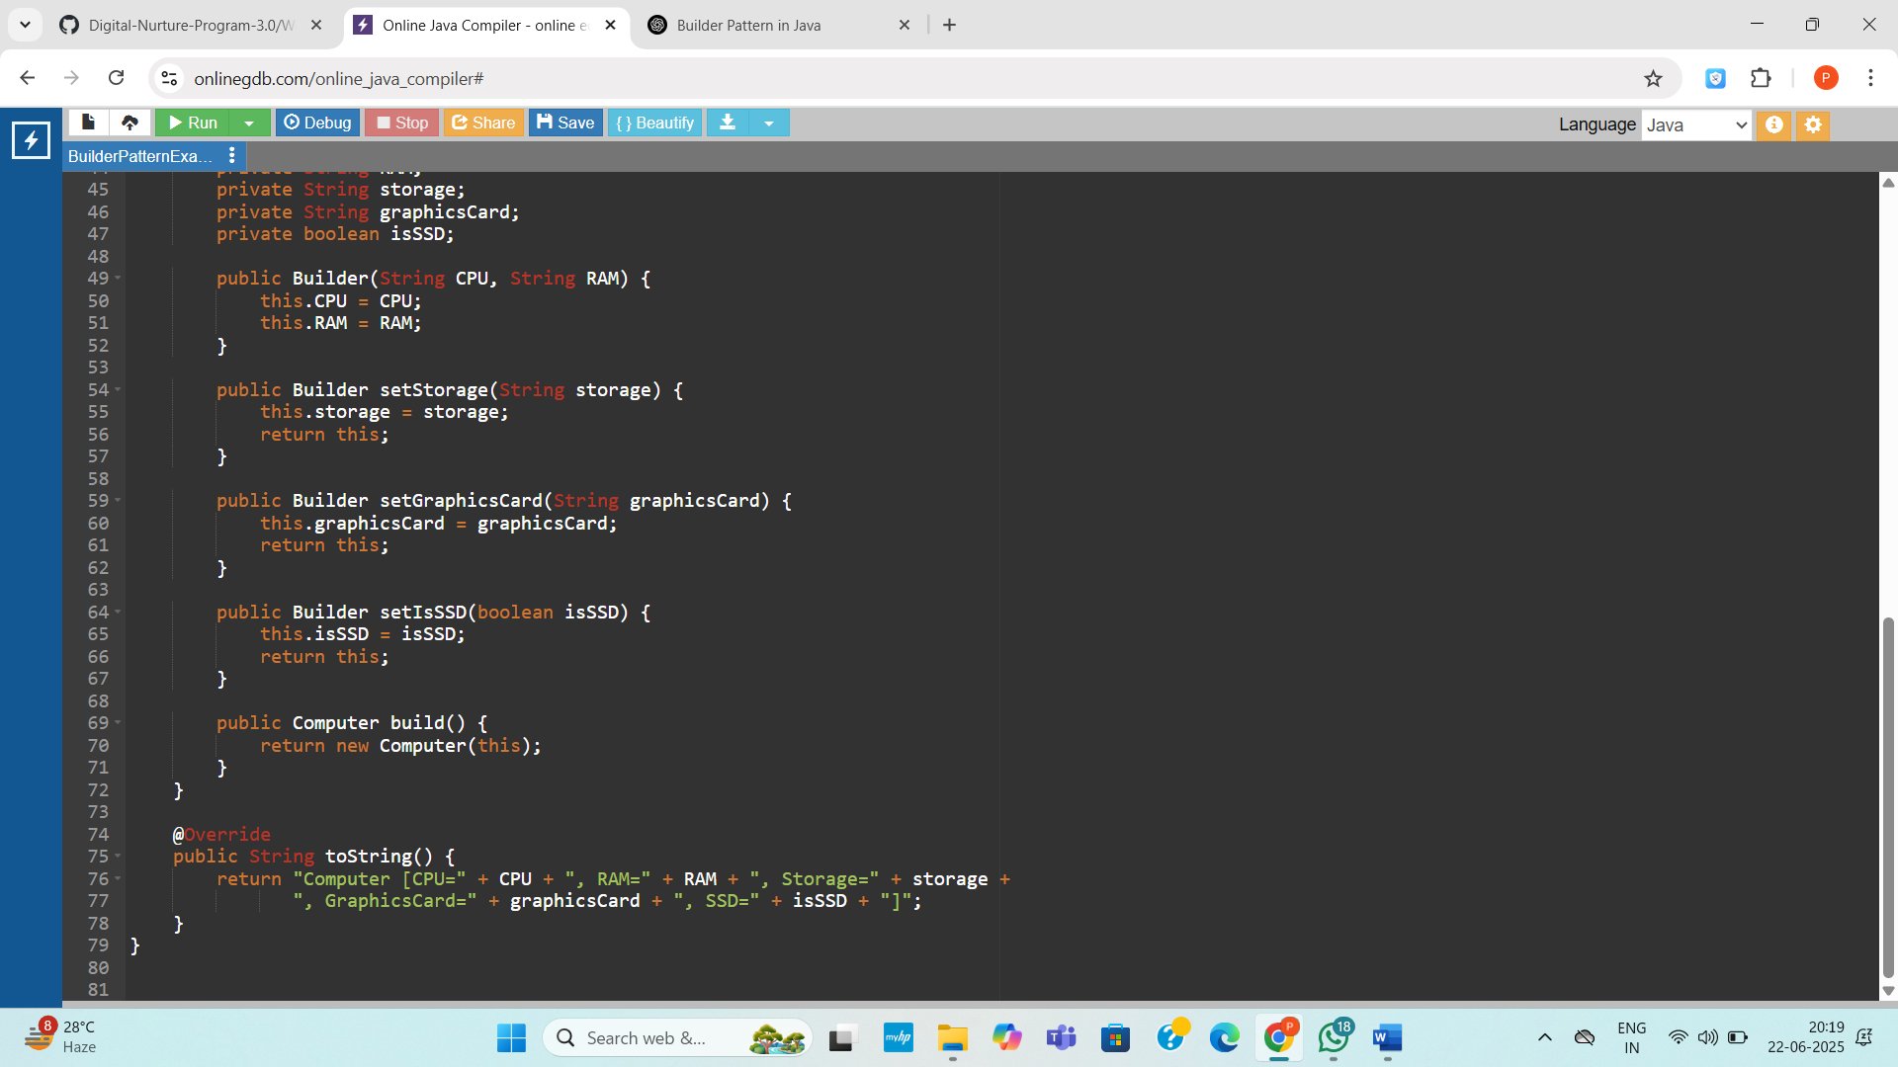

**Output:**

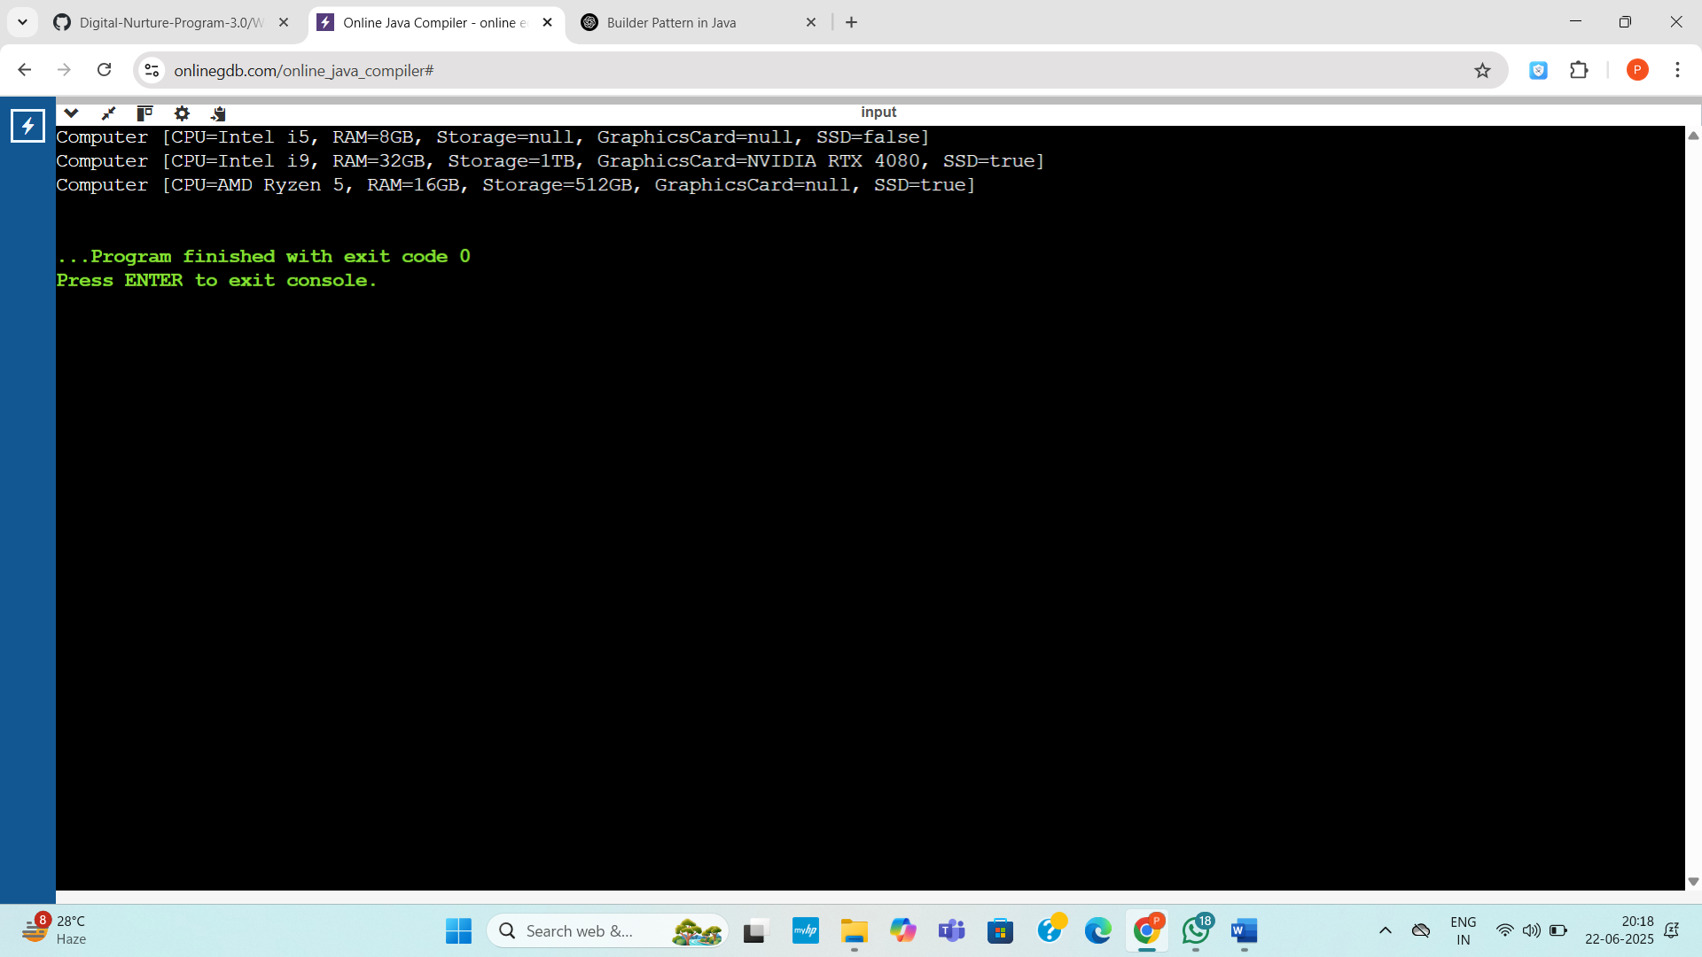

**Exercise 4: Implementing the Adapter Pattern**

**Code:**

public class AdapterPatternExample {

public static void main(String[] args) {

PaymentProcessor paypalProcessor = new PayPalAdapter(new PayPalGateway());

PaymentProcessor stripeProcessor = new StripeAdapter(new StripeGateway());

paypalProcessor.processPayment(99.99);

stripeProcessor.processPayment(149.49);

}

}

interface PaymentProcessor {

void processPayment(double amount);

}

class PayPalGateway {

public void sendPayment(double amountUSD) {

System.out.println("PayPal processed $" + amountUSD);

}

}

class StripeGateway {

public void charge(double amountUSD) {

System.out.println("Stripe charged $" + amountUSD);

}

}

class PayPalAdapter implements PaymentProcessor {

private final PayPalGateway payPal;

public PayPalAdapter(PayPalGateway payPal) {

this.payPal = payPal;

}

public void processPayment(double amount) {

payPal.sendPayment(amount);

}

}

class StripeAdapter implements PaymentProcessor {

private final StripeGateway stripe;

public StripeAdapter(StripeGateway stripe) {

this.stripe = stripe;

}

public void processPayment(double amount) {

stripe.charge(amount);

}

}

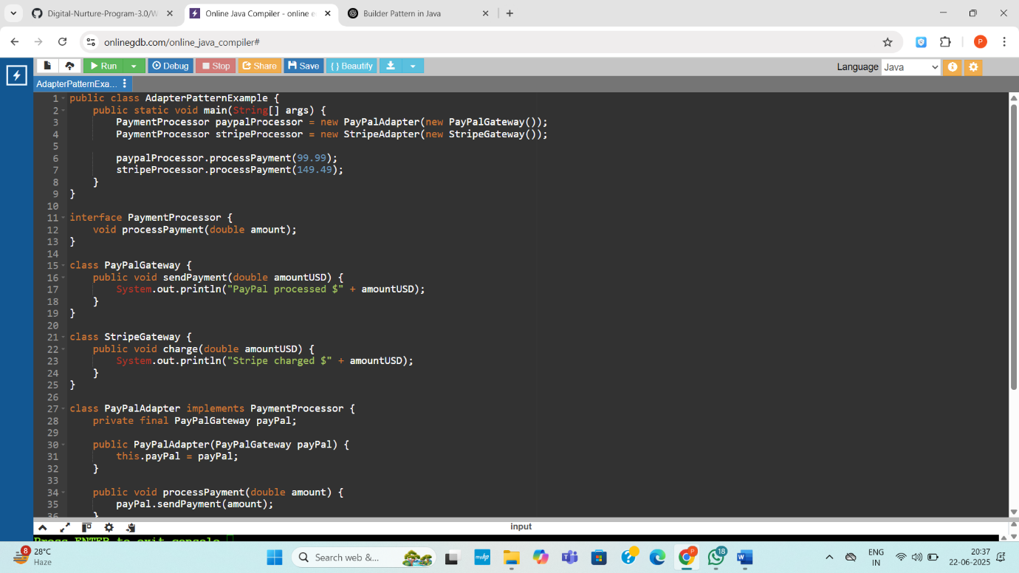

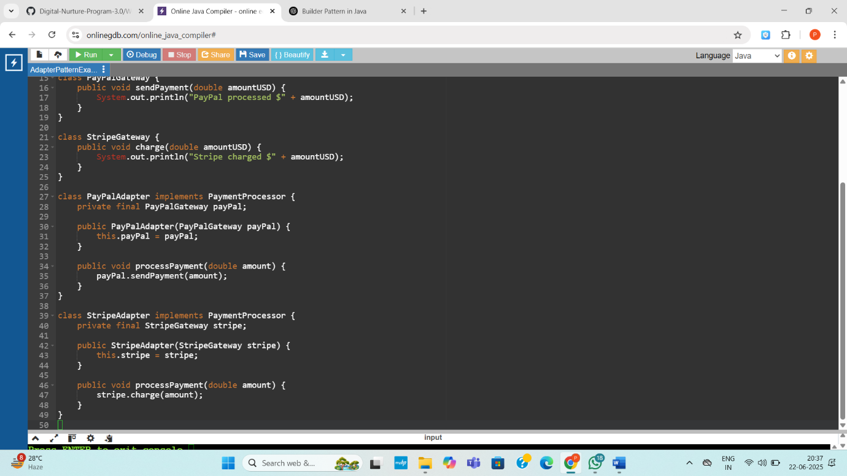

**Output:**

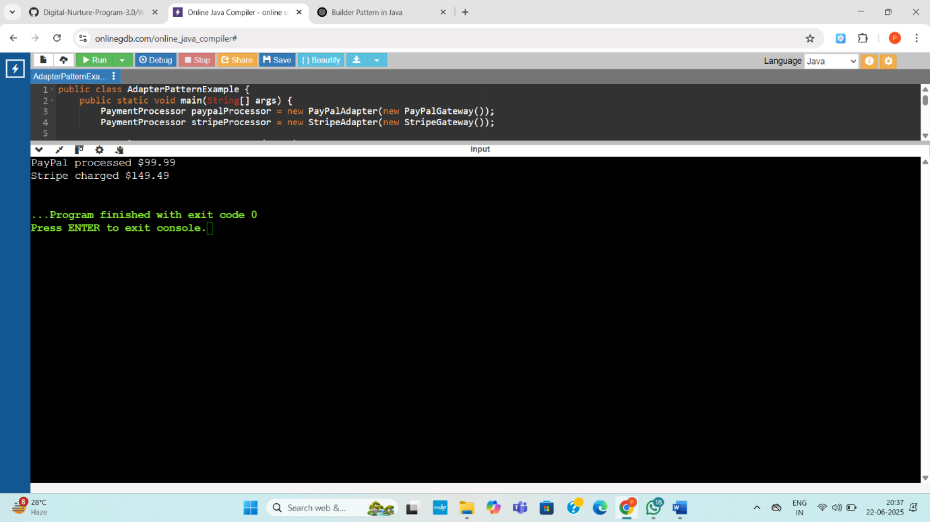

**Exercise 5: Implementing the Decorator Pattern**

**Code:**

public class DecoratorPatternExample {

public static void main(String[] args) {

Notifier basicNotifier = new EmailNotifier();

Notifier smsNotifier = new SMSNotifierDecorator(basicNotifier);

Notifier fullNotifier = new SlackNotifierDecorator(smsNotifier);

System.out.println("=== Only Email ===");

basicNotifier.send();

System.out.println("\n=== Email + SMS ===");

smsNotifier.send();

System.out.println("\n=== Email + SMS + Slack ===");

fullNotifier.send();

}

}

interface Notifier {

void send();

}

class EmailNotifier implements Notifier {

public void send() {

System.out.println("Sending Email Notification");

}

}

abstract class NotifierDecorator implements Notifier {

protected Notifier wrappedNotifier;

public NotifierDecorator(Notifier notifier) {

this.wrappedNotifier = notifier;

}

public void send() {

wrappedNotifier.send();

}

}

class SMSNotifierDecorator extends NotifierDecorator {

public SMSNotifierDecorator(Notifier notifier) {

super(notifier);

}

public void send() {

super.send();

System.out.println("Sending SMS Notification");

}

}

class SlackNotifierDecorator extends NotifierDecorator {

public SlackNotifierDecorator(Notifier notifier) {

super(notifier);

}

public void send() {

super.send();

System.out.println("Sending Slack Notification");

}

}

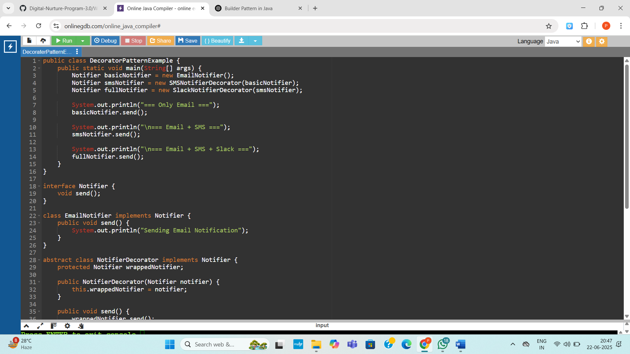

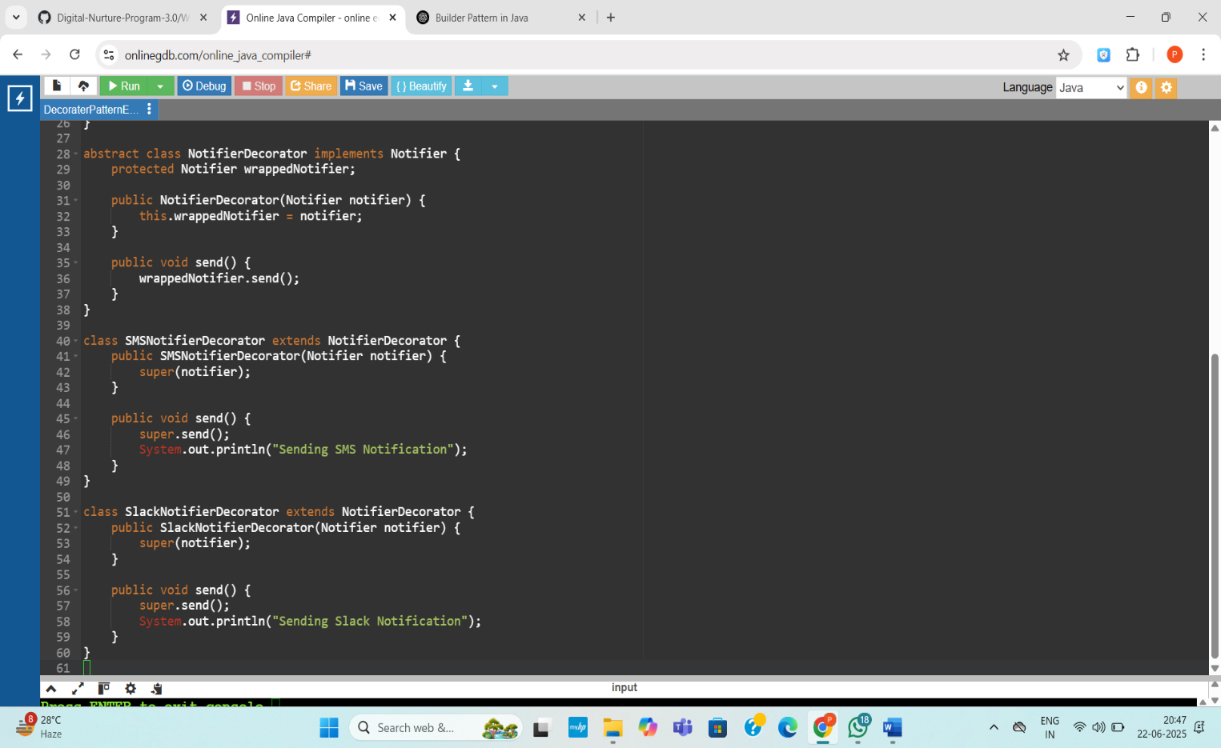

**Output:**

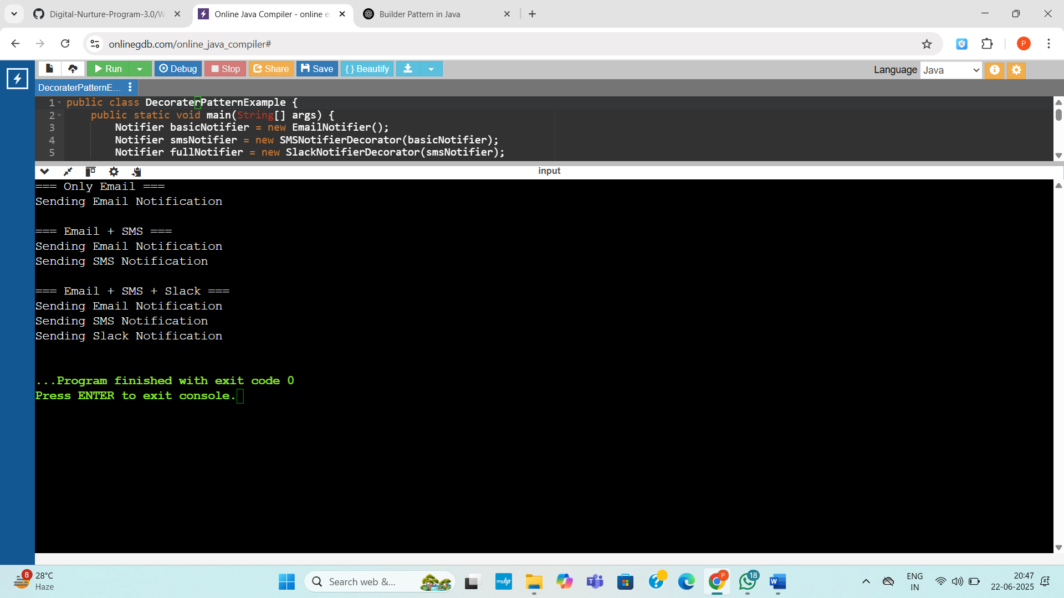

**Exercise 6: Implementing the Proxy Pattern**

**Code:**

public class ProxyPatternExample {

public static void main(String[] args) {

Image img1 = new ProxyImage("photo1.jpg");

Image img2 = new ProxyImage("photo2.jpg");

System.out.println("First call to img1:");

img1.display();

System.out.println("\nSecond call to img1 (cached):");

img1.display();

System.out.println("\nFirst call to img2:");

img2.display();

}

}

interface Image {

void display();

}

class RealImage implements Image {

private String filename;

public RealImage(String filename) {

this.filename = filename;

loadFromRemoteServer();

}

private void loadFromRemoteServer() {

System.out.println("Loading image from server: " + filename);

}

public void display() {

System.out.println("Displaying image: " + filename);

}

}

class ProxyImage implements Image {

private RealImage realImage;

private String filename;

public ProxyImage(String filename) {

this.filename = filename;

}

public void display() {

if (realImage == null) {

realImage = new RealImage(filename);

}

realImage.display();

}

}

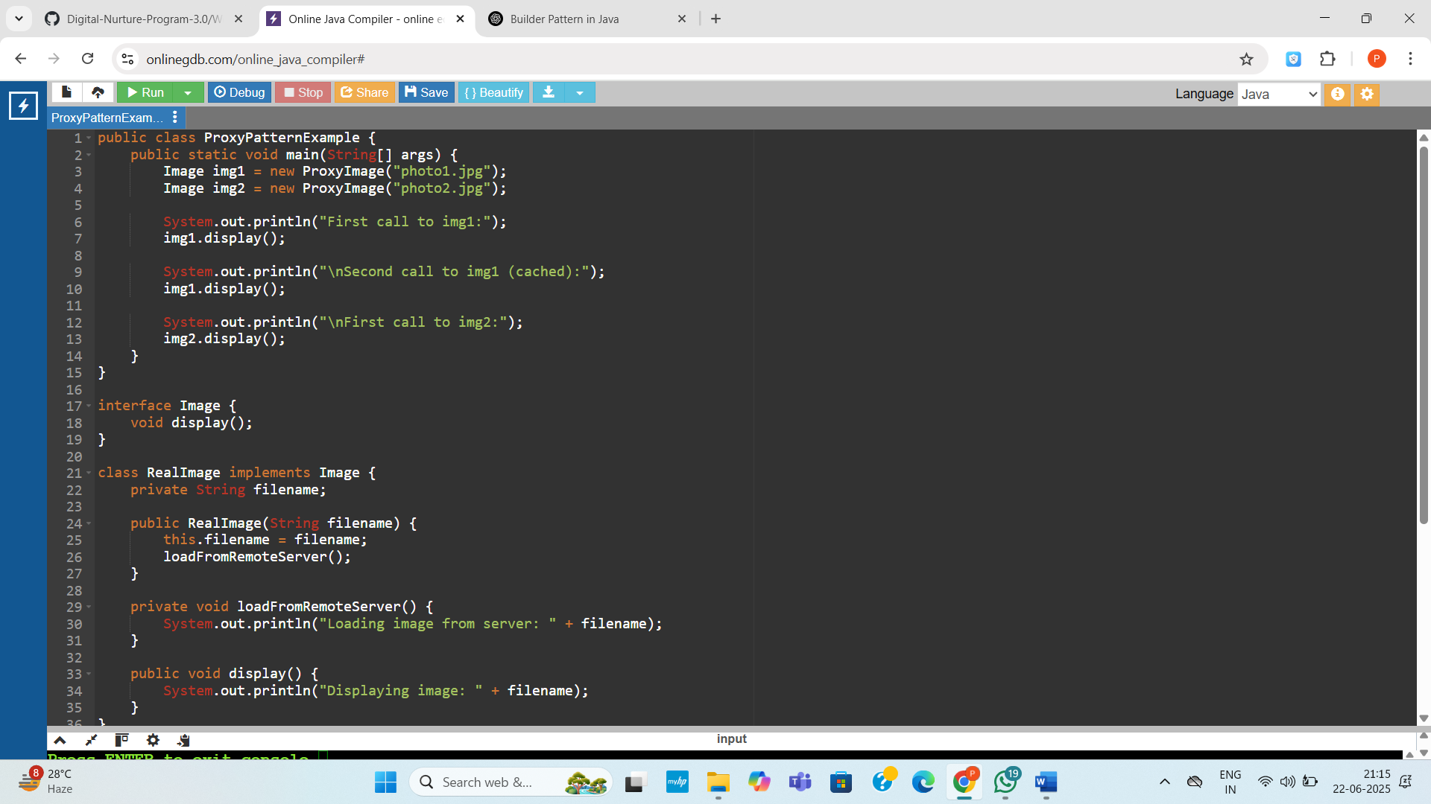

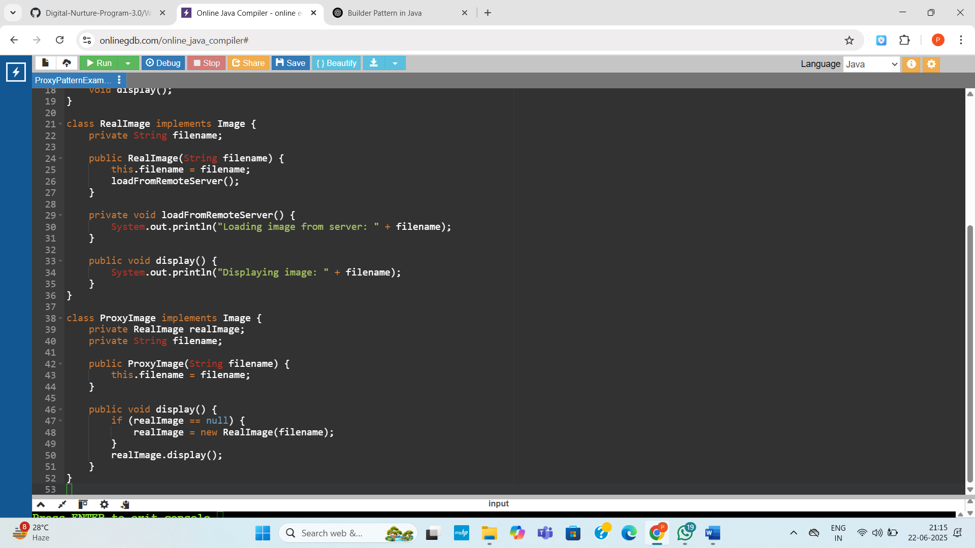

**Output:**

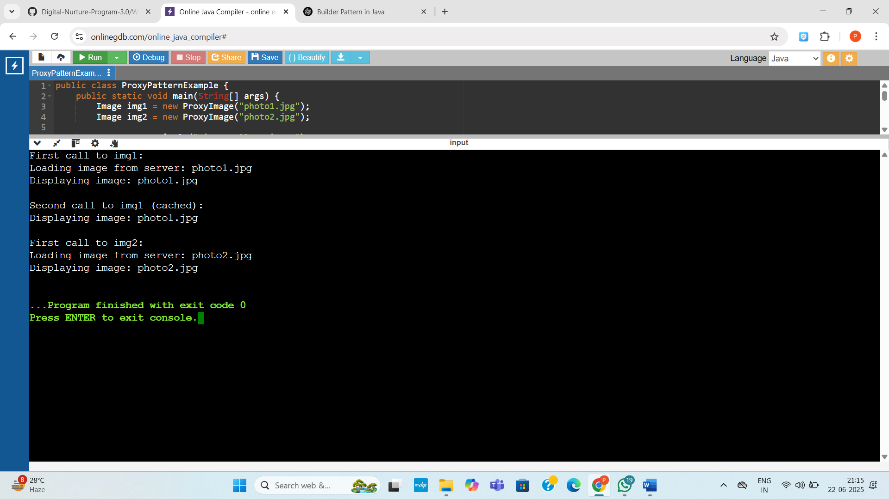

**Exercise 7: Implementing the Observer Pattern**

**Code:**

import java.util.*;

public class ObserverPatternExample {

public static void main(String[] args) {

StockMarket stockMarket = new StockMarket();

Observer mobileApp = new MobileApp("MobileApp 1");

Observer webApp = new WebApp("WebApp 1");

stockMarket.registerObserver(mobileApp);

stockMarket.registerObserver(webApp);

System.out.println("Updating stock price...");

stockMarket.setStockPrice("AAPL", 185.50);

System.out.println("Updating stock price again...");

stockMarket.setStockPrice("GOOG", 2760.25);

stockMarket.removeObserver(webApp);

System.out.println("Updating stock price again...");

stockMarket.setStockPrice("AAPL", 190.75);

}

}

interface Stock {

void registerObserver(Observer o);

void removeObserver(Observer o);

void notifyObservers(String stock, double price);

}

class StockMarket implements Stock {

private List<Observer> observers = new ArrayList<>();

private Map<String, Double> stockPrices = new HashMap<>();

public void registerObserver(Observer o) {

observers.add(o);

}

public void removeObserver(Observer o) {

observers.remove(o);

}

public void notifyObservers(String stock, double price) {

for (Observer o : observers) {

o.update(stock, price);

}

}

public void setStockPrice(String stock, double price) {

stockPrices.put(stock, price);

notifyObservers(stock, price);

}

}

interface Observer {

void update(String stock, double price);

}

class MobileApp implements Observer {

private String name;

public MobileApp(String name) {

this.name = name;

}

public void update(String stock, double price) {

System.out.println(name + " received update: " + stock + " = $" + price);

}

}

class WebApp implements Observer {

private String name;

public WebApp(String name) {

this.name = name;

}

public void update(String stock, double price) {

System.out.println(name + " received update: " + stock + " = $" + price);

}

}

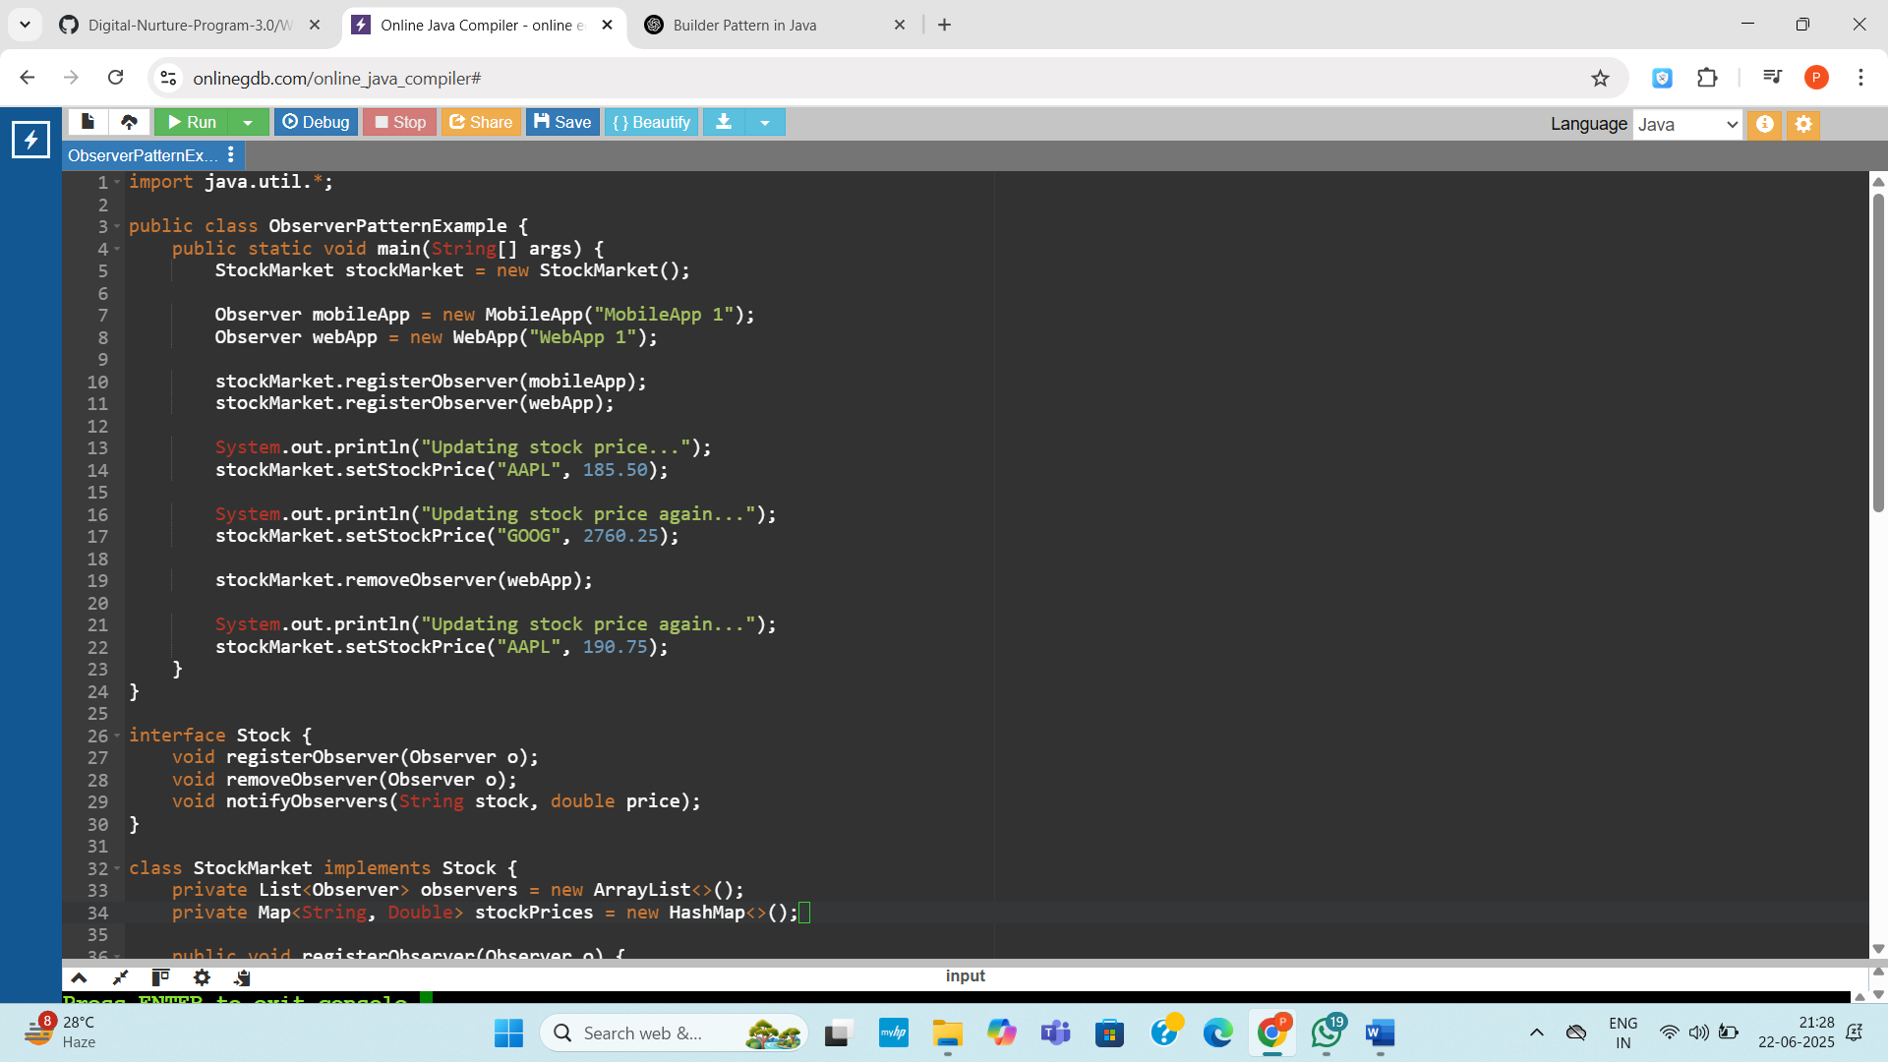

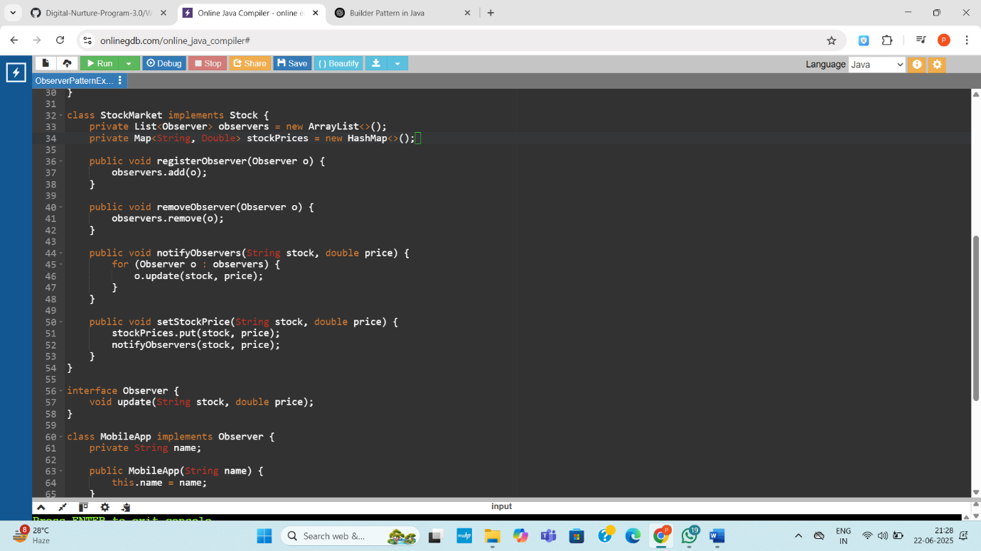

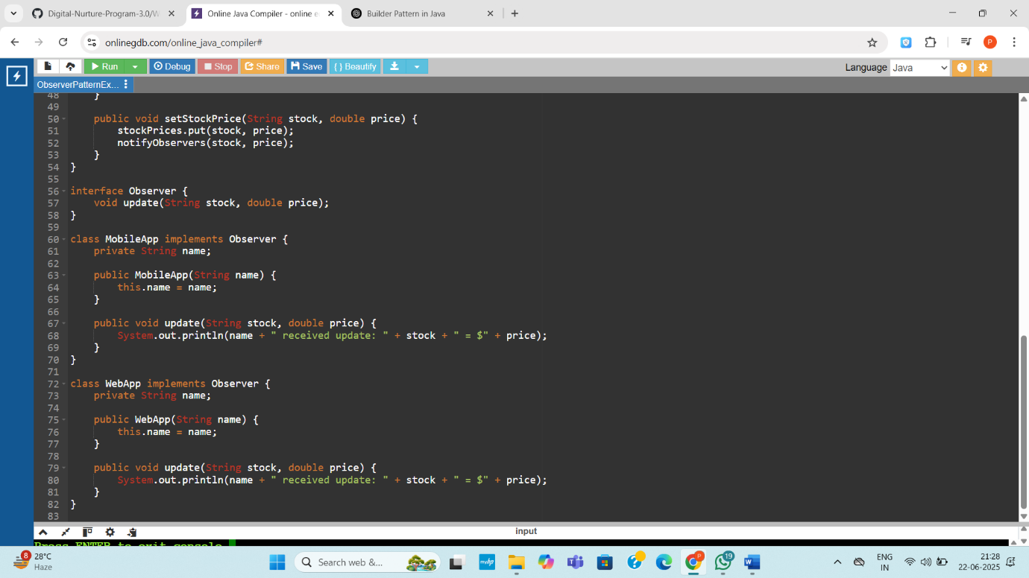

**Output:**

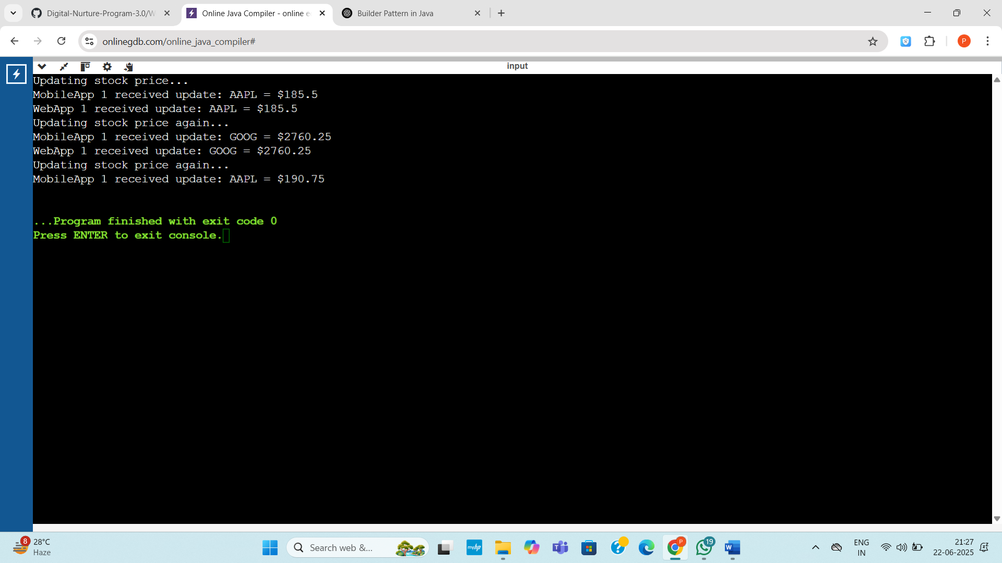

**Exercise 8: Implementing the Strategy Pattern**

**Code:**

public class StrategyPatternExample {

public static void main(String[] args) {

PaymentContext context = new PaymentContext();

System.out.println("Paying with Credit Card:");

context.setPaymentStrategy(new CreditCardPayment());

context.pay(100.0);

System.out.println("\nPaying with PayPal:");

context.setPaymentStrategy(new PayPalPayment());

context.pay(250.5);

}

}

interface PaymentStrategy {

void pay(double amount);

}

class CreditCardPayment implements PaymentStrategy {

public void pay(double amount) {

System.out.println("Paid ₹" + amount + " using Credit Card.");

}

}

class PayPalPayment implements PaymentStrategy {

public void pay(double amount) {

System.out.println("Paid ₹" + amount + " using PayPal.");

}

}

class PaymentContext {

private PaymentStrategy strategy;

public void setPaymentStrategy(PaymentStrategy strategy) {

this.strategy = strategy;

}

public void pay(double amount) {

if (strategy != null) {

strategy.pay(amount);

} else {

System.out.println("Payment method not selected.");

}

}

}

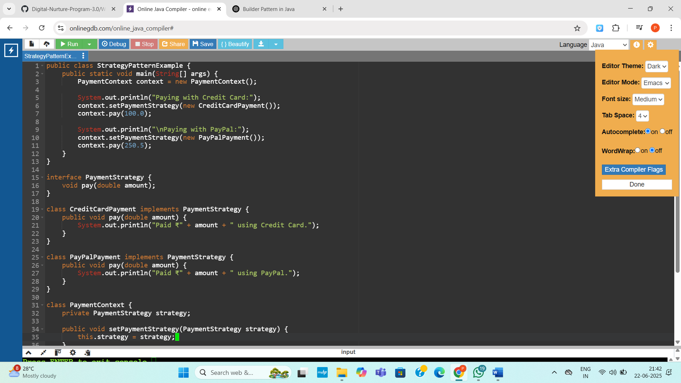

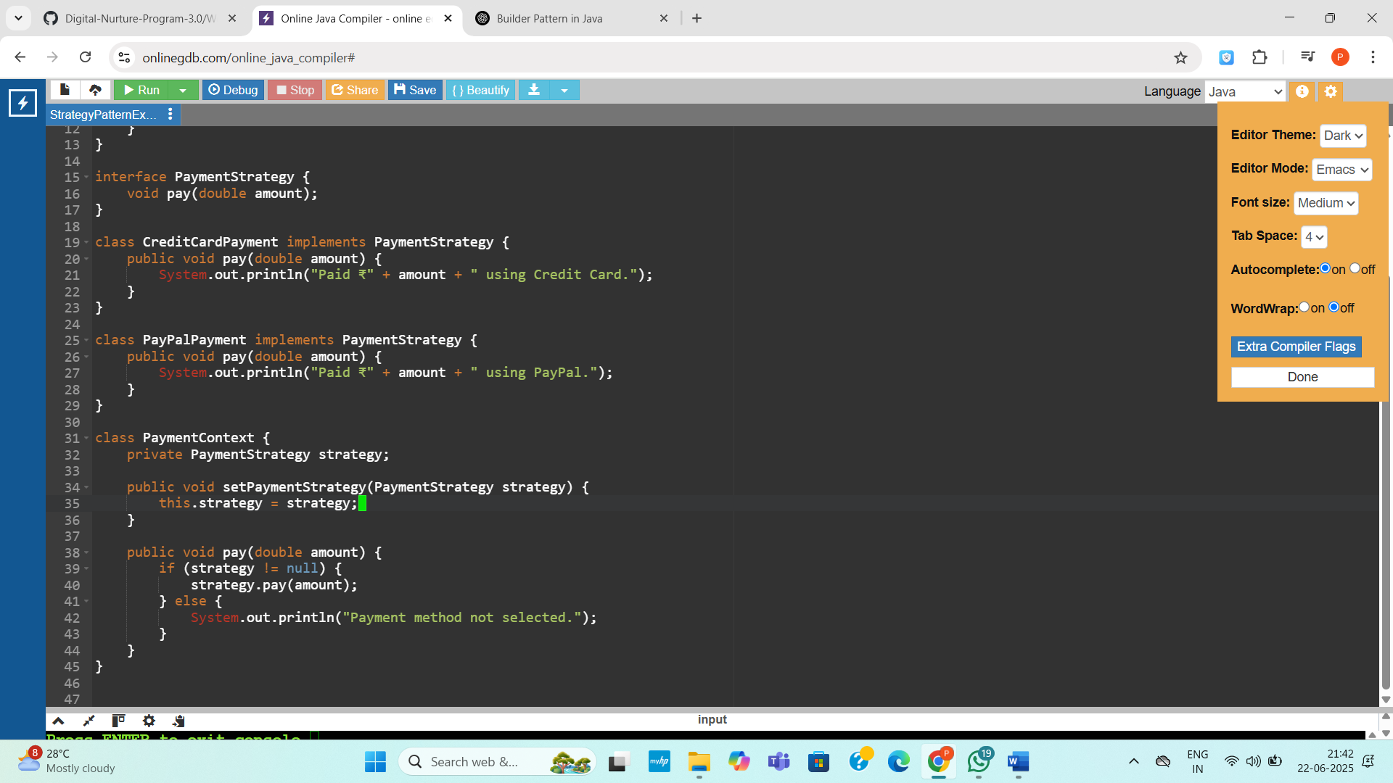

**Output:**

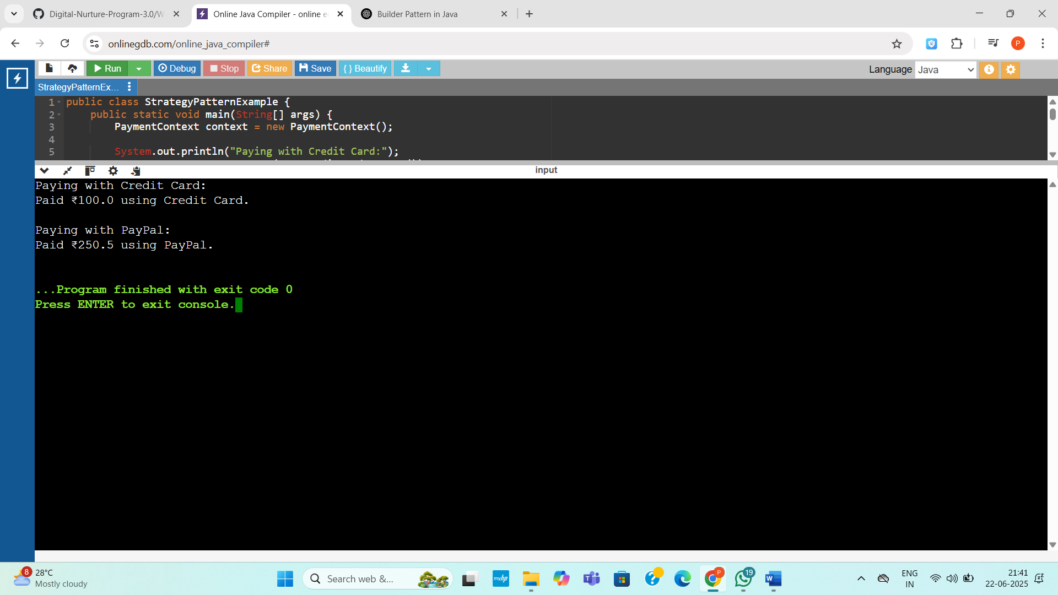

**Exercise 9: Implementing the Command Pattern**

**Code:**

public class CommandPatternExample {

public static void main(String[] args) {

Light livingRoomLight = new Light();

Command lightOn = new LightOnCommand(livingRoomLight);

Command lightOff = new LightOffCommand(livingRoomLight);

RemoteControl remote = new RemoteControl();

remote.setCommand(lightOn);

remote.pressButton();

remote.setCommand(lightOff);

remote.pressButton();

}

}

interface Command {

void execute();

}

class Light {

public void turnOn() {

System.out.println("Light is ON");

}

public void turnOff() {

System.out.println("Light is OFF");

}

}

class LightOnCommand implements Command {

private Light light;

public LightOnCommand(Light light) {

this.light = light;

}

public void execute() {

light.turnOn();

}

}

class LightOffCommand implements Command {

private Light light;

public LightOffCommand(Light light) {

this.light = light;

}

public void execute() {

light.turnOff();

}

}

class RemoteControl {

private Command command;

public void setCommand(Command command) {

this.command = command;

}

public void pressButton() {

if (command != null) {

command.execute();

} else {

System.out.println("No command assigned.");

}

}

}

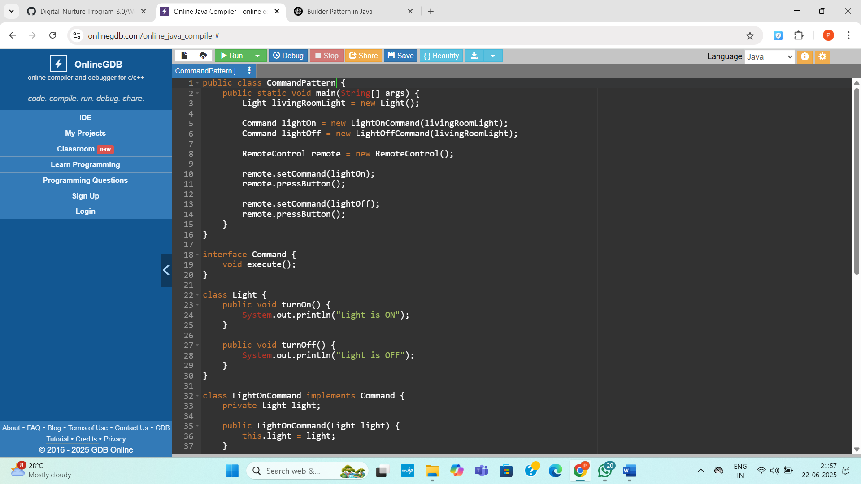

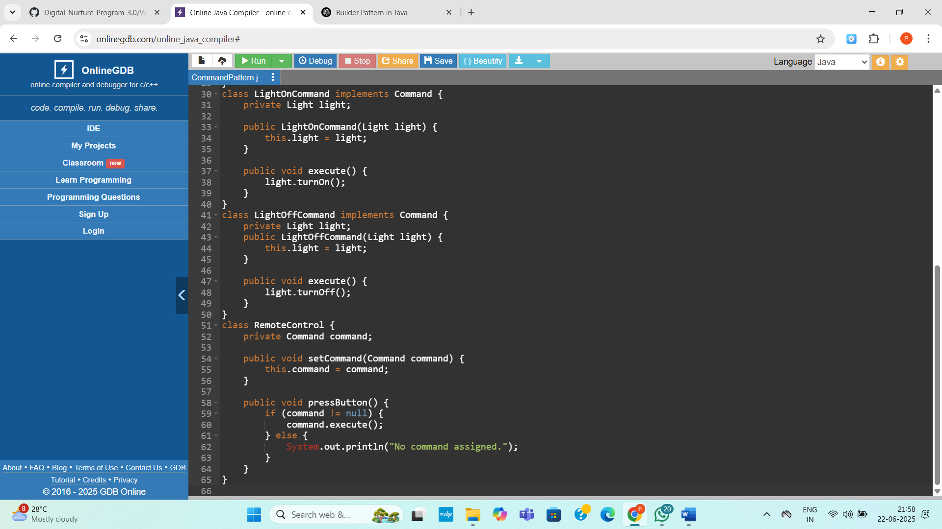

Output:

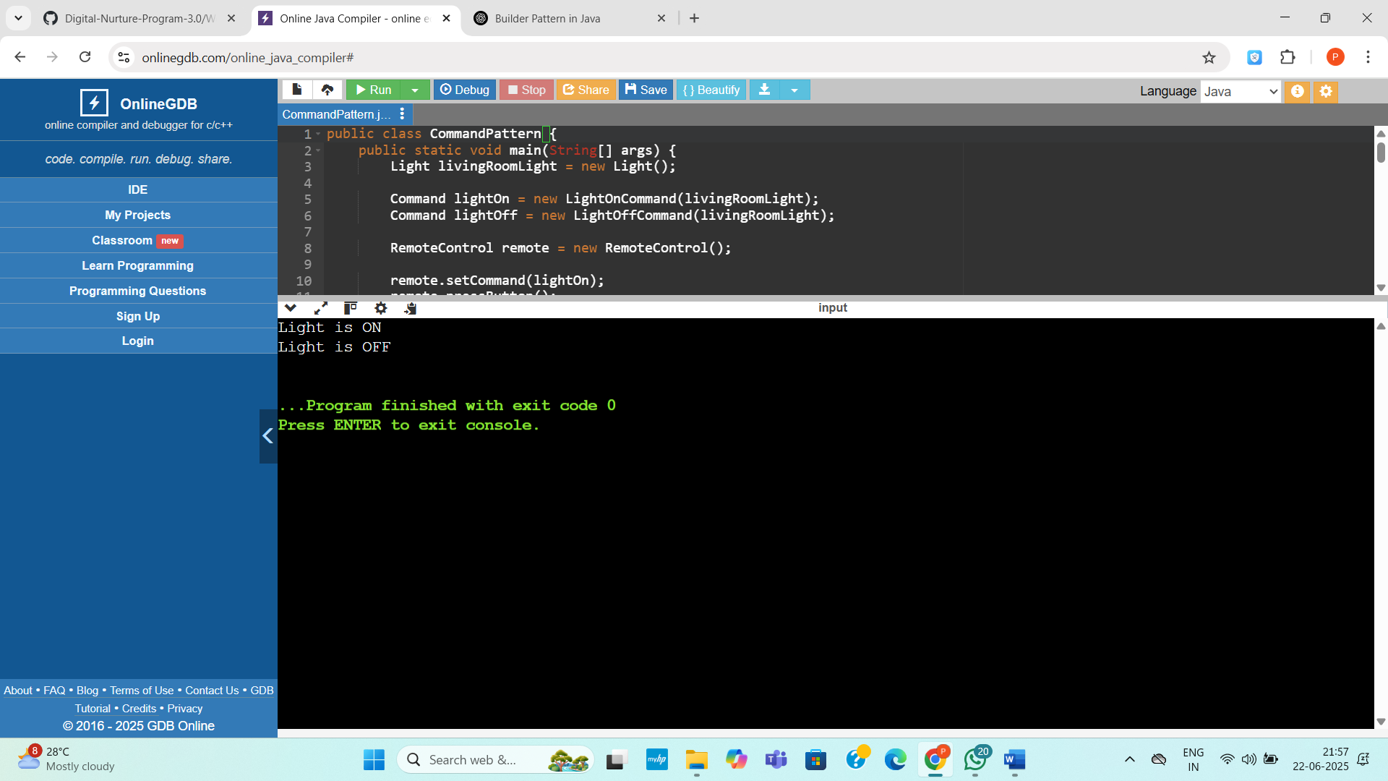

**Exercise 10: Implementing the MVC Pattern**

**Code:**

public class MVCPatternExample {

public static void main(String[] args) {

Student model = new Student("Priya", "S101", "A");

StudentView view = new StudentView();

StudentController controller = new StudentController(model, view);

controller.updateView();

controller.setStudentName("Anita");

controller.setStudentGrade("A+");

controller.updateView();

}

}

class Student {

private String name;

private String id;

private String grade;

public Student(String name, String id, String grade) {

this.name = name;

this.id = id;

this.grade = grade;

}

public String getName() {

return name;

}

public String getId() {

return id;

}

public String getGrade() {

return grade;

}

public void setName(String name) {

this.name = name;

}

public void setId(String id) {

this.id = id;

}

public void setGrade(String grade) {

this.grade = grade;

}

}

class StudentView {

public void displayStudentDetails(String name, String id, String grade) {

System.out.println("Student Details:");

System.out.println("Name: " + name);

System.out.println("ID: " + id);

System.out.println("Grade: " + grade);

System.out.println();

}

}

class StudentController {

private Student model;

private StudentView view;

public StudentController(Student model, StudentView view) {

this.model = model;

this.view = view;

}

public void setStudentName(String name) {

model.setName(name);

}

public void setStudentId(String id) {

model.setId(id);

}

public void setStudentGrade(String grade) {

model.setGrade(grade);

}

public String getStudentName() {

return model.getName();

}

public String getStudentId() {

return model.getId();

}

public String getStudentGrade() {

return model.getGrade();

}

public void updateView() {

view.displayStudentDetails(model.getName(), model.getId(), model.getGrade());

}

}

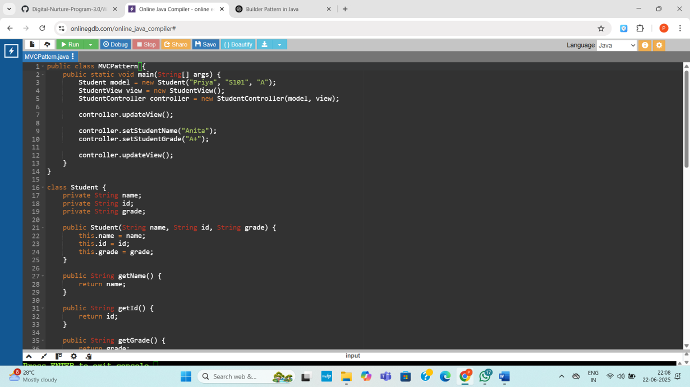

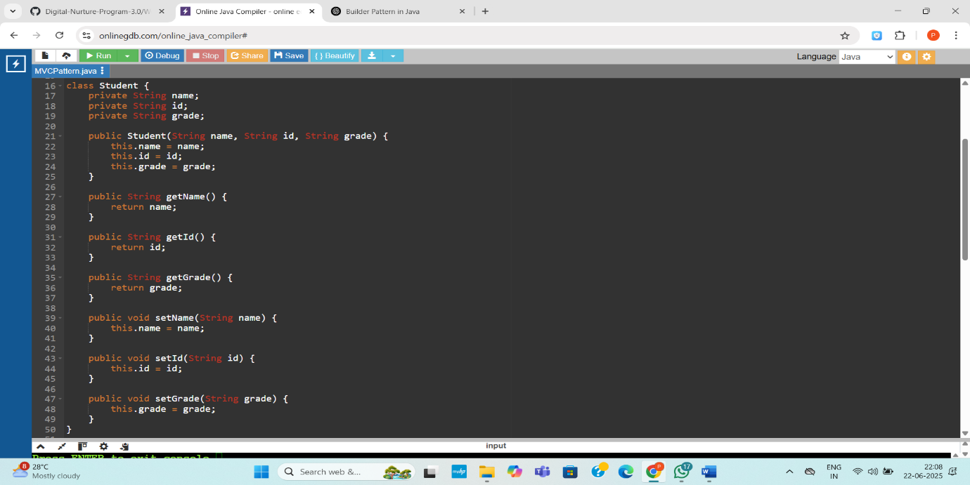

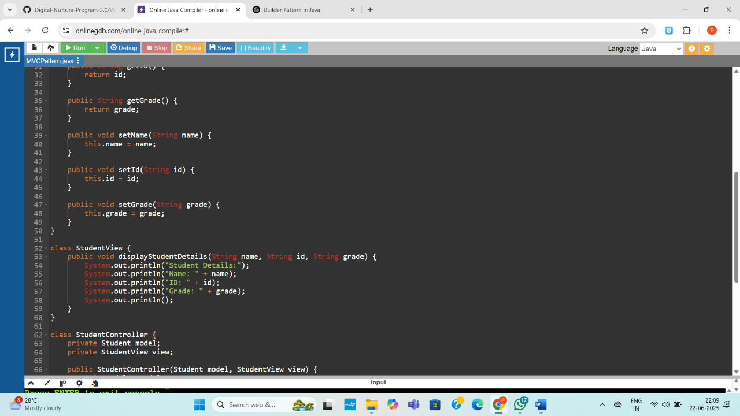

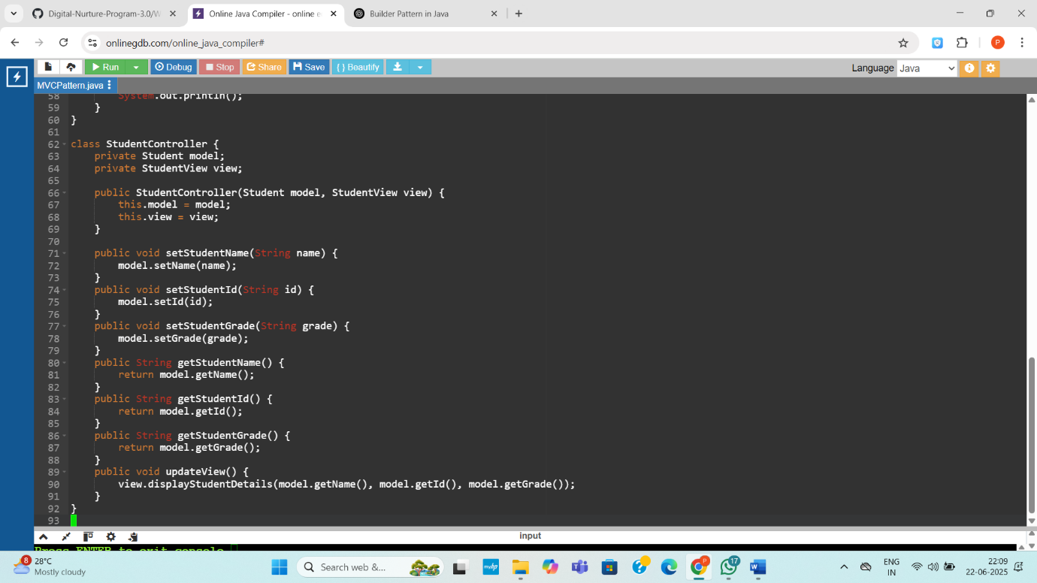

**Output:**

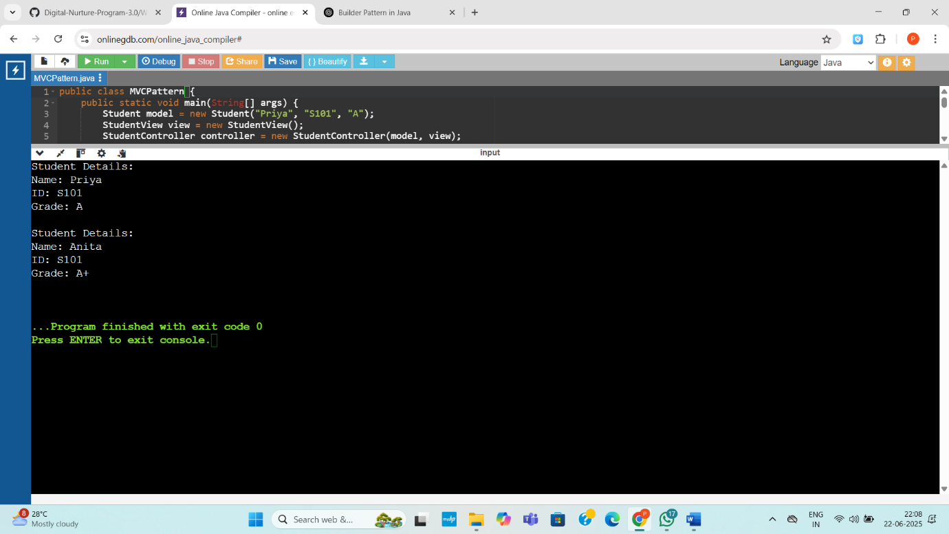

Exercise 11: Implementing Dependency Injection

**Code:**

import java.util.*;

public class DependencyInjectionExample {

public static void main(String[] args) {

CustomerRepository repository = new CustomerRepositoryImpl();

CustomerService service = new CustomerService(repository);

Customer customer1 = service.findCustomerById("C001");

Customer customer2 = service.findCustomerById("C999");

System.out.println(customer1);

System.out.println(customer2);

}

}

class Customer {

private String id;

private String name;

public Customer(String id, String name) {

this.id = id;

this.name = name;

}

public String toString() {

if (id == null || name == null) {

return "Customer not found";

}

return "Customer[id=" + id + ", name=" + name + "]";

}

}

interface CustomerRepository {

Customer findCustomerById(String id);

}

class CustomerRepositoryImpl implements CustomerRepository {

private Map<String, Customer> database = new HashMap<>();

public CustomerRepositoryImpl() {

database.put("C001", new Customer("C001", "Alice"));

database.put("C002", new Customer("C002", "Bob"));

}

public Customer findCustomerById(String id) {

return database.getOrDefault(id, new Customer(null, null));

}

}

class CustomerService {

private final CustomerRepository repository;

public CustomerService(CustomerRepository repository) {

this.repository = repository;

}

public Customer findCustomerById(String id) {

return repository.findCustomerById(id);

}

}

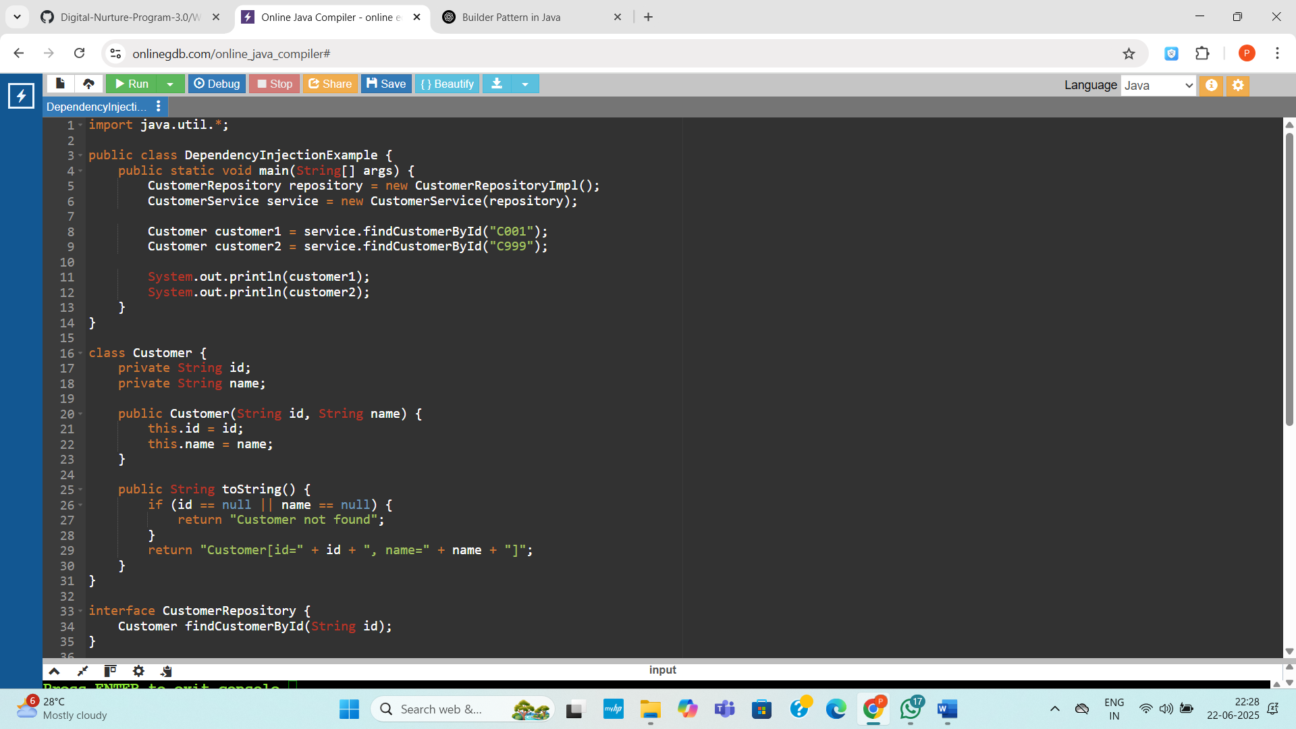

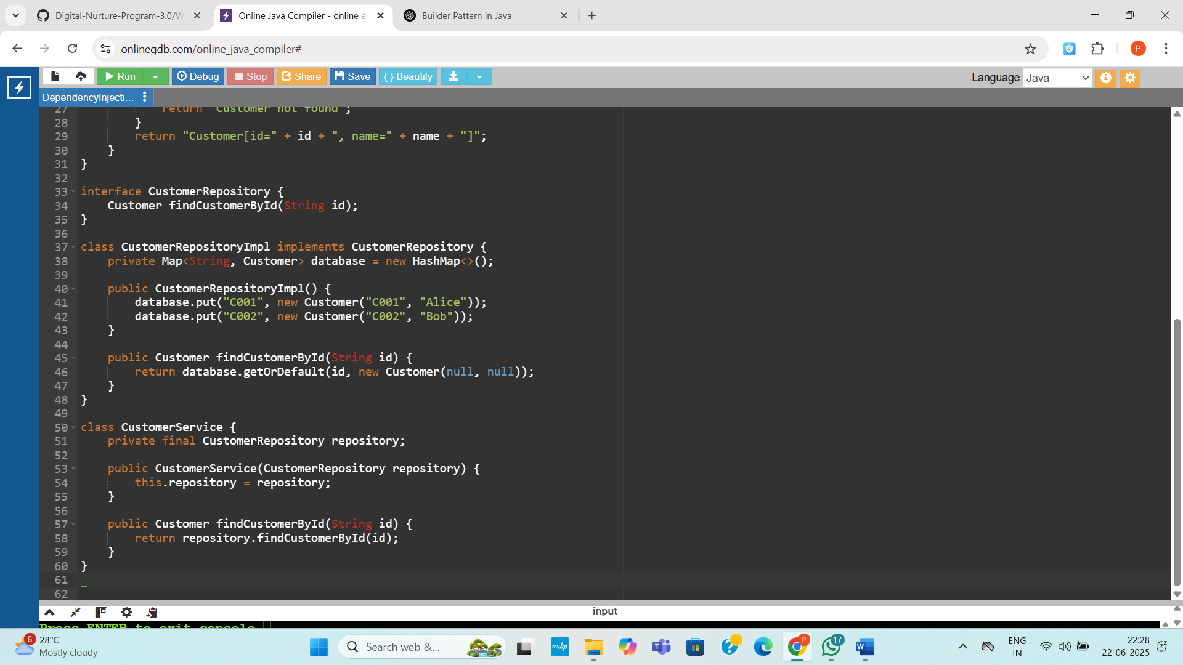

**Output:**

